Predicting Loan Outcomes for Lending Clubs

Vincent Jiang and Nisreen Shiban

Abhishek Malali

Pavlos Protopapas, Kevin Rader, Weiwei Pan/CS109a

6 December 2016

**Abstract**

Many peer-to-peer loans are unsecured personal loans that are not protected by guarantor, or collateralized by a lien. In cases of bankruptcy, liquidation and defaults of the borrowers, the lenders may put their investment at great risk if not knowing adequate information about the loans. Institutional investors and financial intermediaries may have access to high quality data and sophisticated mathematical model for predicting loans outcomes and assigning grades. Retail lenders and investors on the other hand are not exposed to such means and resources. Therefore, a comprehensive tool that may extrapolate from publically available data and builds efficient and inexpensive model is need to determine the quality of a loan.

**Introduction**

Peer-to-peer (P2P) lending online platforms put burrowers in contact with lenders. The business model for P2P lending companies has a simpler business model than conventional financial institutions. They do not capture deposits, they are not restricted by banking regulations, and they do not maintain idle balances so they bear less of the transaction costs. Importantly, P2P lenders use technology o reduce operating costs, which keeps interest rates low. P2P lending additionally reduces credit rationing, which is great for borrowers placed in the long tail of credit who are willing to pay higher interest rates.

Despite all of these advantages, there are failures associated with P2P lending. First of all, P2P lending individual investors bear the credit risk, unlike financial institutions with their skilled financial analysts. Because they are at a disadvantage facing the borrower, P2P lenders suffer from the problem of information asymmetry. For this reason, P2P lending sites provide potential lenders with information about borrowers and their loan purpose, including the external credit scores, or information extracted from the platform itself, such as the grade assigned to each loan.

The report aims to find if a grade that qualifies the loan along with loan and borrower characteristics reduces information asymmetry and explains loan default. A regression logistic model was tested for prediction of loan default based on the information provided. The data used was from Lending Club, a US P2P lending site. The factors that were shown to explain default were loan purpose, annual income, current housing situation, credit history and indebtedness. Loan amount and length of employment do not seem to significantly contribute to loan default. Finally, the grade assigned by the P2P lending site was shown to be the best predictive factor of default, but information like the borrowers’ debt level is still required.

**Project Outline**

**Methods**

Load and Cleanse Data

Load dataset and perform initial cleansing. Cleansing will entail removing features that only contain NaN values, imputing values into features that have a large proportion of NaN values, and changing feature data types in order to perform correlation analysis. Our numerical imputing will be done by populating NaNs with the column average. For categorical data, we will replace NaNs with the most frequent words/modes. For practical purpose, we also eliminate all Current Loans because they are the loans whose status we want to predict instead of including them in either our training or testing dataset.

When we load the data, we get a data frame with dimensions (887379, 74). This means that there are 887,379 individuals to whose information we have access, and that there are 74 different features about these individuals we can explore. Of those 74, 73 will act as potential predictors and one will act as our

As we see, quite a lot of columns have NaN values. We see what percentage of values is NaN.



As we see, a large amount of data is missing. We would need to deal with that later, when we use some model to do prediction. For now, we keep them.

We now look at distributions of values in each column.

As a start, we draw a histogram for each column and then dig into features that are the most interesting/representative.

We'll start by looking at numerical features:

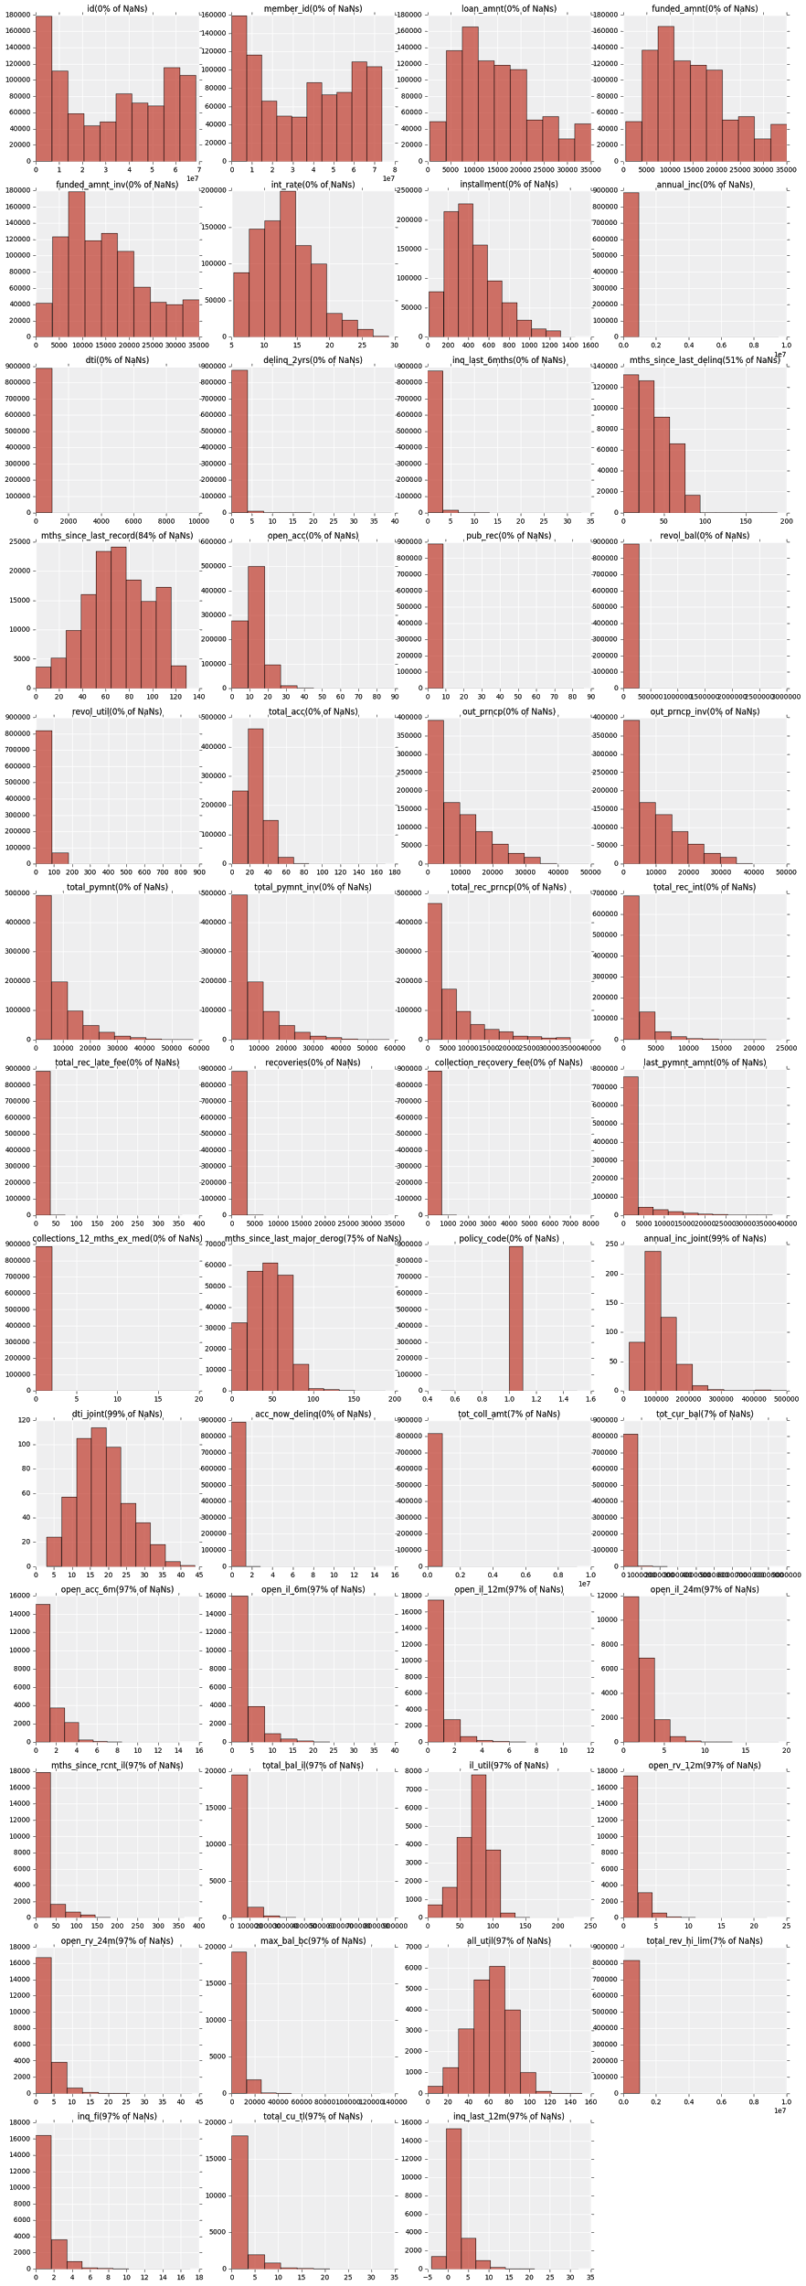



From a very cursory glance, we can see, that number of features have nice distribution. On the other hand, some features mostly contain a single value - those would probably not be informative. But there are outliers that need to be kept in mind.

Next, we'll plot categorical features to look at their distributions:

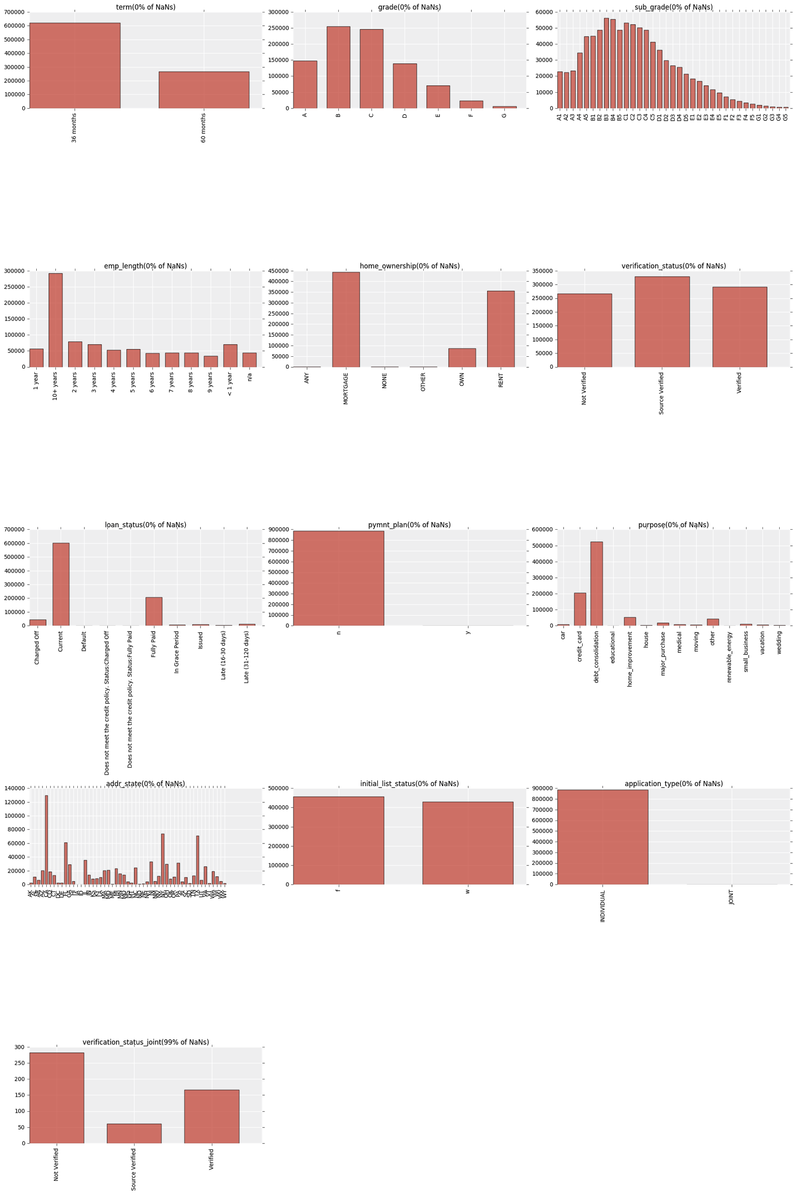



We can see that the “grade” and “subgrade” categories are included. We know that these two categories must be removed as it is the Lending Club classification scheme, and it should not influence our classification.

As we're trying to predict loan status, we look at it closer:

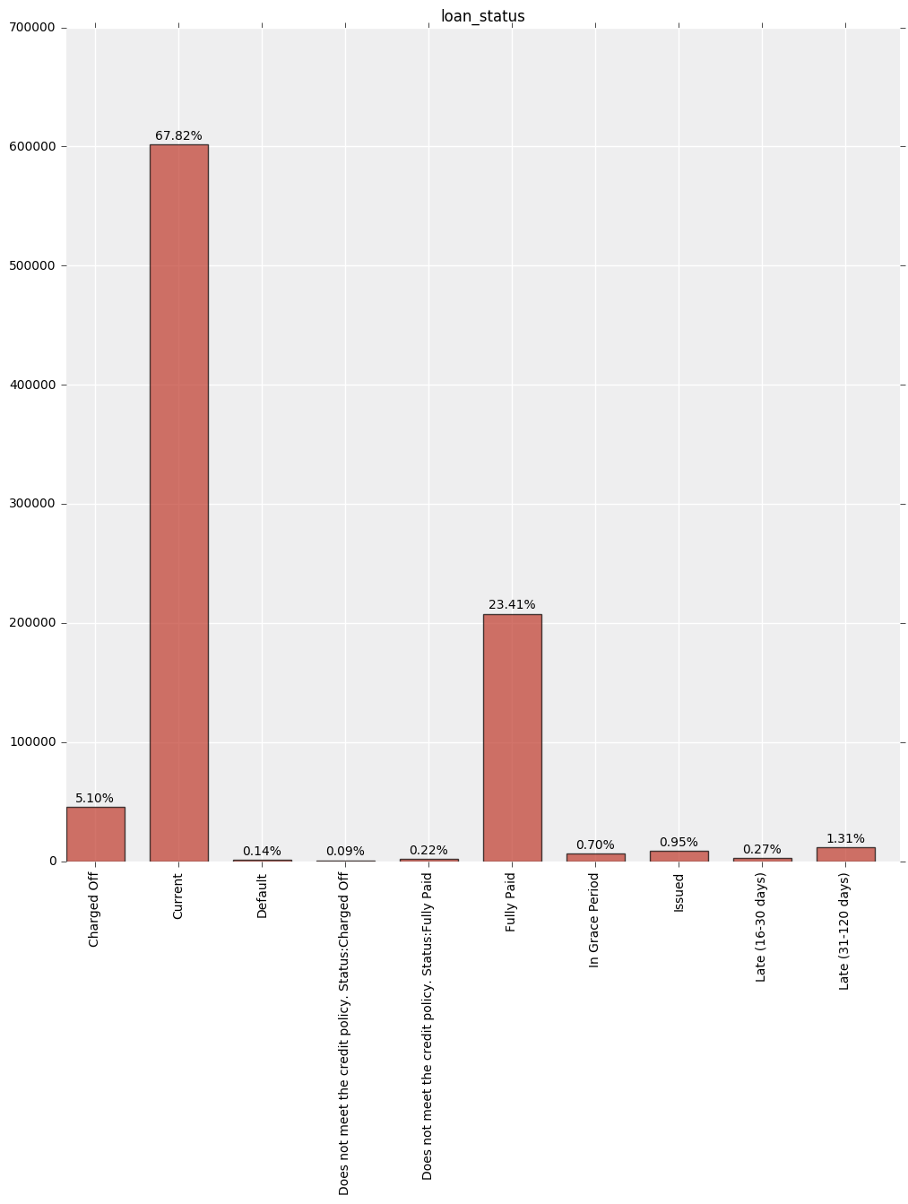

We must remove Current and Issued Loans because they cannot be used to inform our model. We also thought to combine certain categories together that seem to encode similar information, but we decided to leave the categories as they are now in case there is a distinction

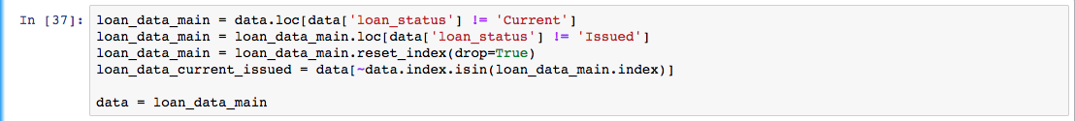

After removing the “Current” and “Issued” data, the dimensions of our data are (277140, 74), which means that we now have only 277,140 who will be used to train and test our model. We also checked if the distributions of the predictors changed dramatically after this step, and we observed no obvious difference except for verification_status_joint, which had an opposing trend (see attached Ipython Notebook files).

Feature Selecting

Since there are so many features, we can't explore all of them. To find out what features are relevant, we'll train Random Forest classifier. It provides off-shelf feature importance mechanism that we'll use in order to understand what features are most relevant to prediction task.

For simple random forest model, we'll perform one-hot-encoding on categorical features and change all NaNs to column means (or mode for categorical).

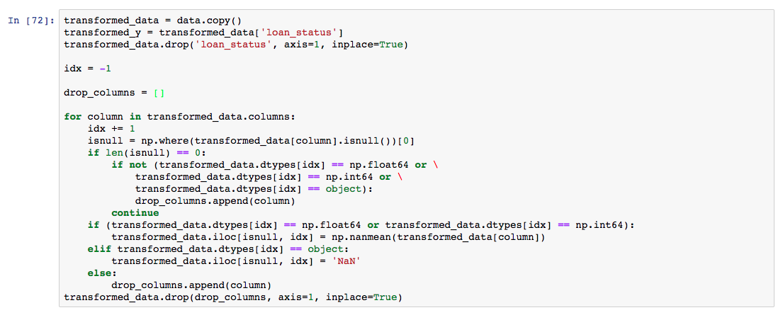

We drop all categorical columns that have > threshold_count unique values.

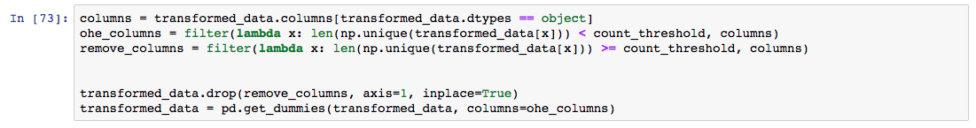

Now we can train random forest to get feature importances. Since the dataset is large, we'll randomly take only 10% of it for speed purposes.

To check whether we chose a representative sample from data, We look at distribution of loan statuses in initial data and selected part of the data.

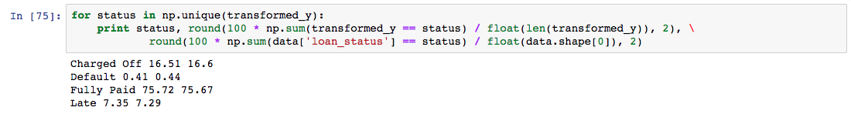

That looks nice. Now we can train random forest.

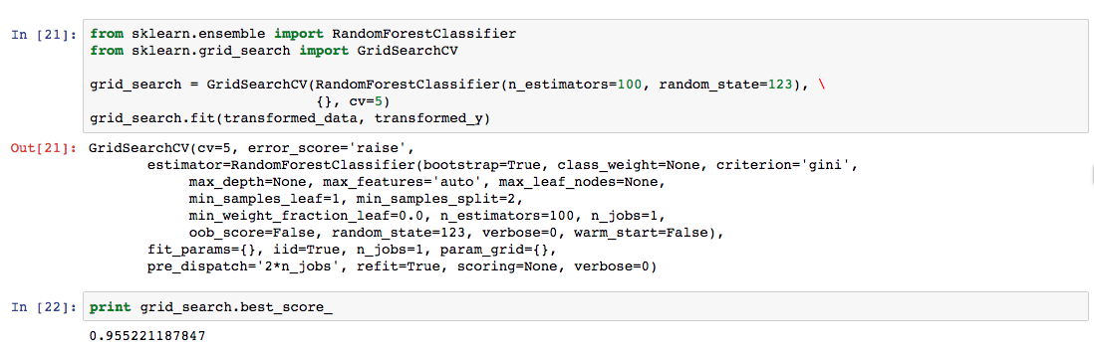

As we can see, model already works great. At this points, it’s not really clear whether we overfit the data (since we used KFold as a cross-validation).

We plot feature importances to see what columns are most relevant to classification task.

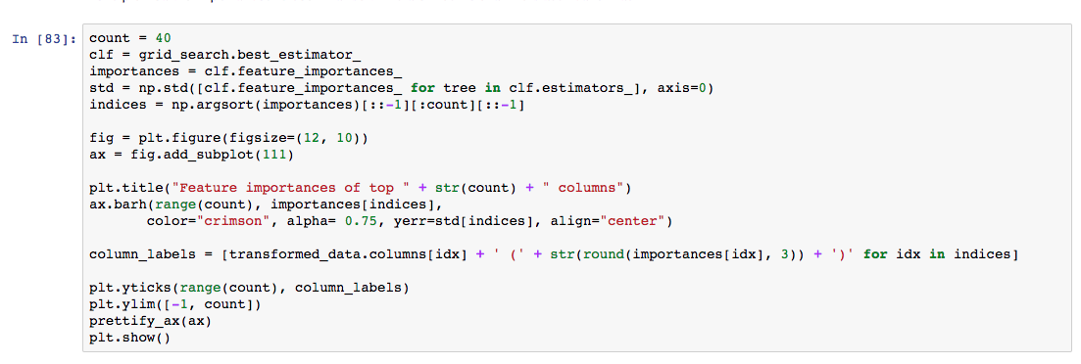

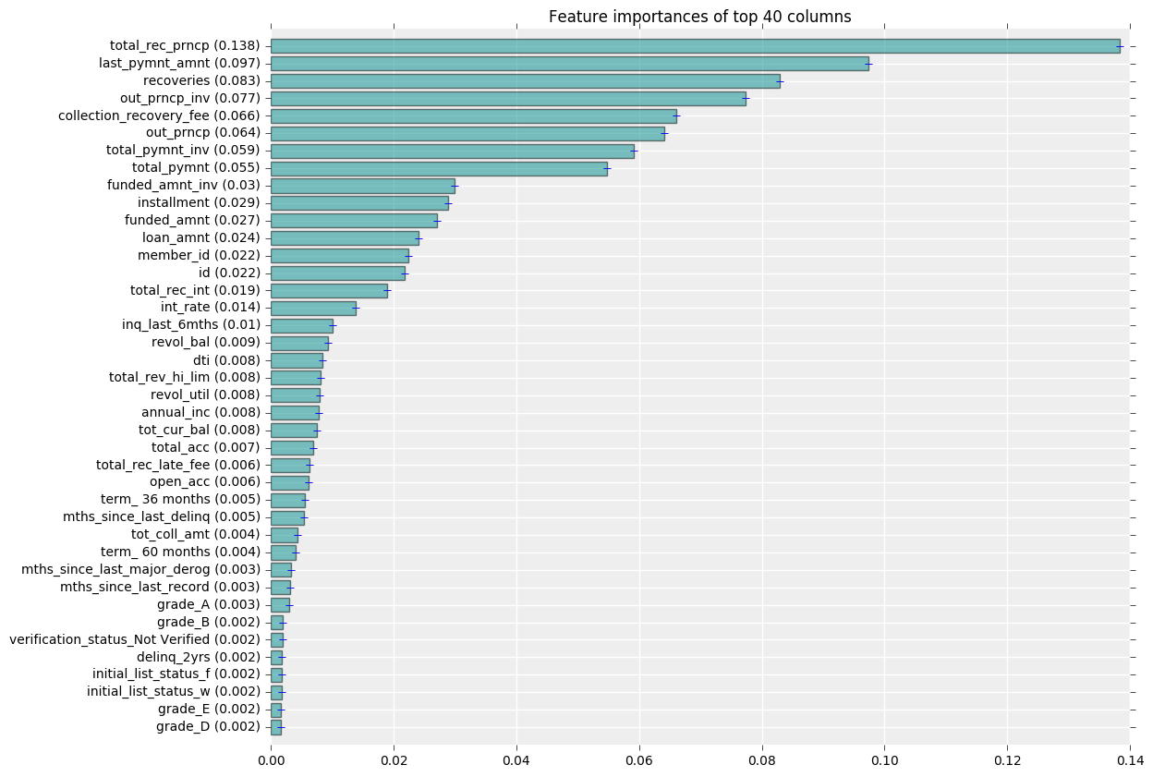

From the plot above, we see, that feature importances drop to zero quite rapidly. Only 30 features (in this simple model, we really need to be skeptical of it) contain useful information. We dive more deeply into top importances found by looking at the variable distributions.

Histogram of total_rec_prncp (remaining outstanding principal for total amount funded):

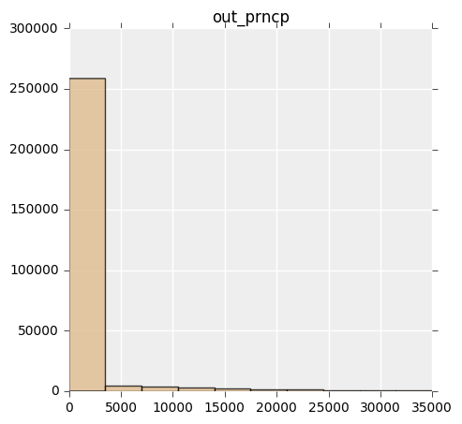

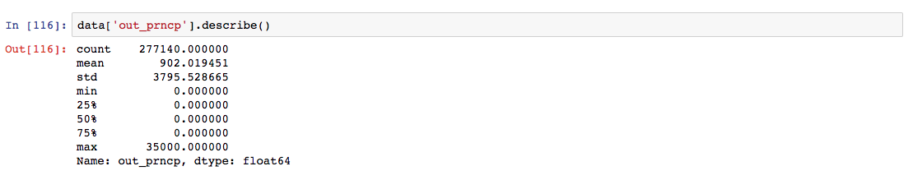

Such exponential-like distributions are usually good to take log of.

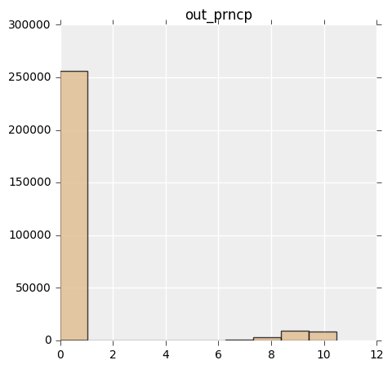

Now we see there's a gap between the data and hopefully that helps the classifier to predict the outcome.

Histogram of out_prncp_inv (Remaining outstanding principal for portion of total amount funded by investors):

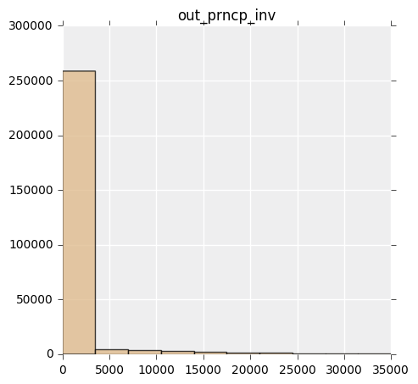

This feature seems to highly correlate with out_prncp. We find out:

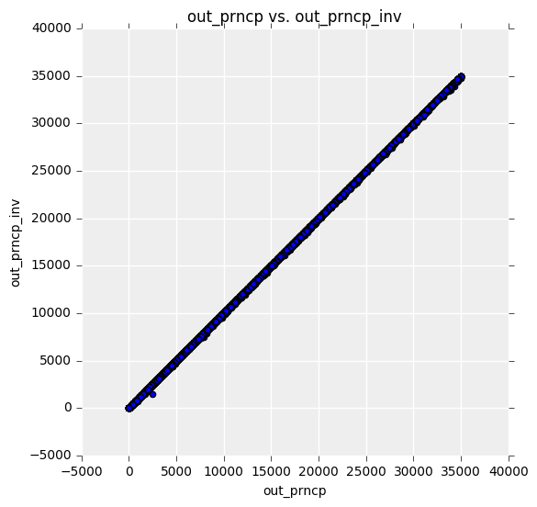

As you can see in the plot above, there's a strong linear correlation between these two features.

We look at the residuals:

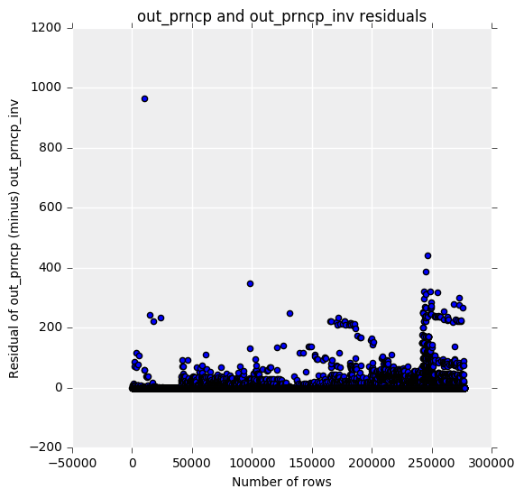

We see, that out_prncp is always bigger that out_prncp_inv. We probably don't need both out_prncp_inv and out_prncp.

**But**, the difference between them can have information in it, so we'll add a column out_prncp_difference to our dataset.

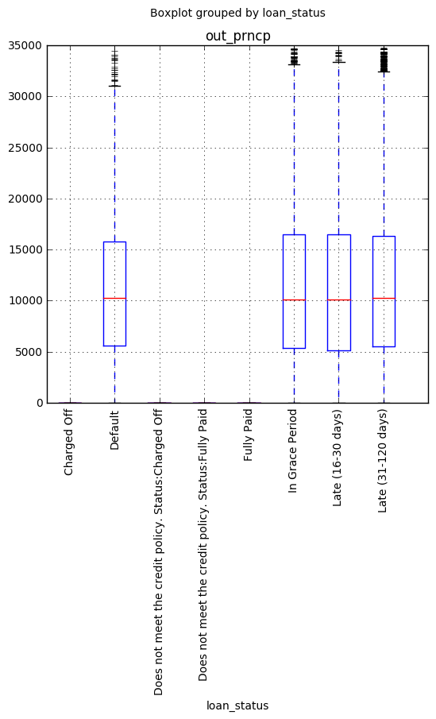

We can immediately see, that "Charged Off", "Fully Paid" "Does not meet the credit policy Status: Charged Off" and "Does not meet the credit policy Status: Fully Paid" has very small values of column out_prncp.

We see whether there's a relationship between loan status and difference between out_prncp and out_prncp_inv:

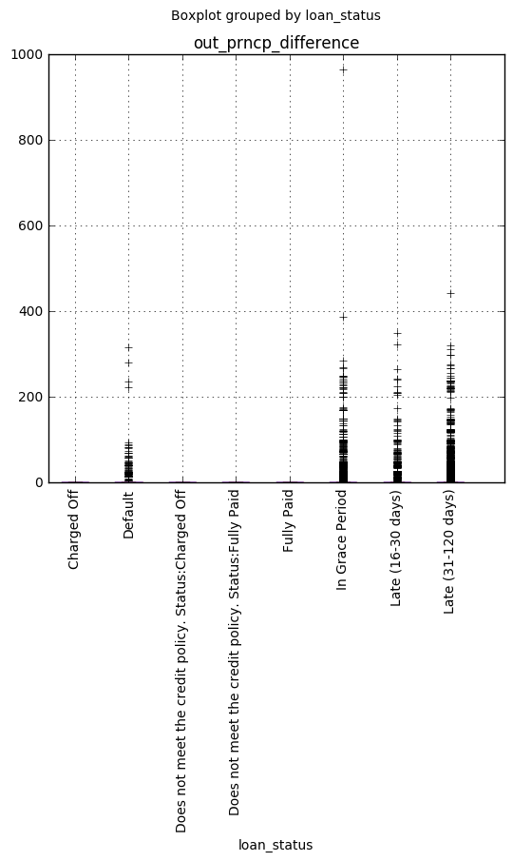

It turned out to be just like previous plot - four loan statuses mentioned above differ from others.

Histogram of last_pymnt_amnt (Last total payment amount received):

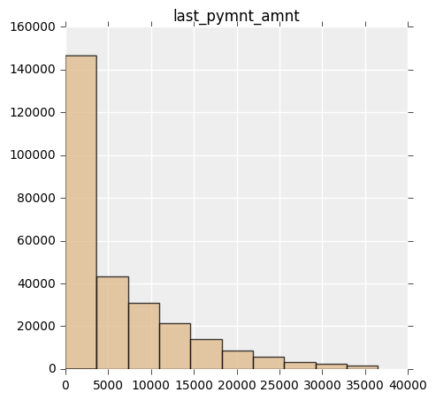

We should also take log here.

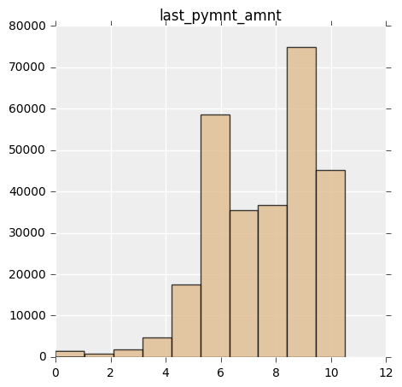

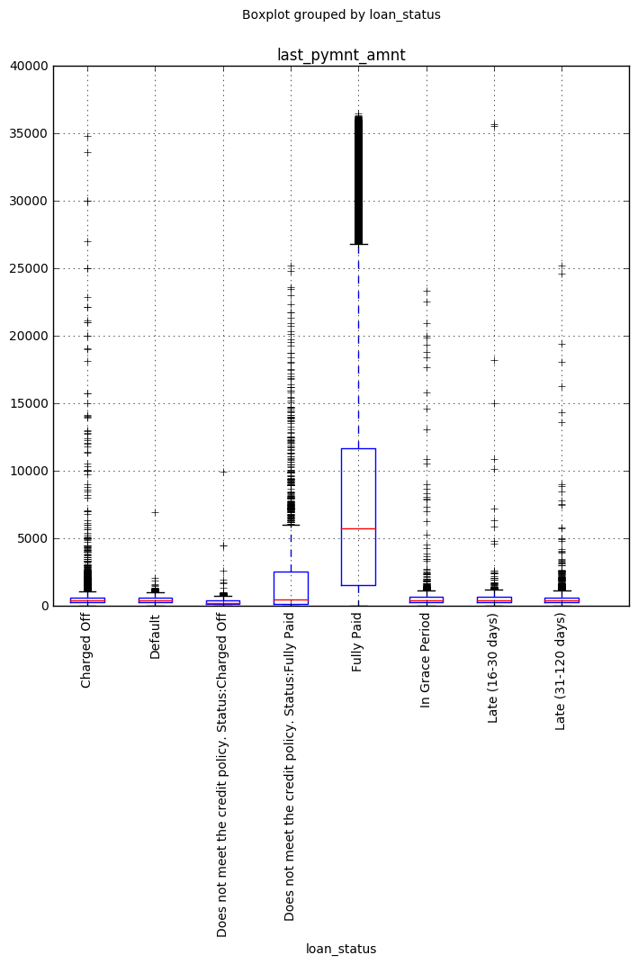

We see, that distribution are really different, that's why random forest can infer useful information from it.

Surprisingly, Random Forest found a relationship between unique Id for each person to loan outcome. That can be a sign that data came from different sources and in each source, there were different distributions of loan statuses.

We’ll further explore this fact.

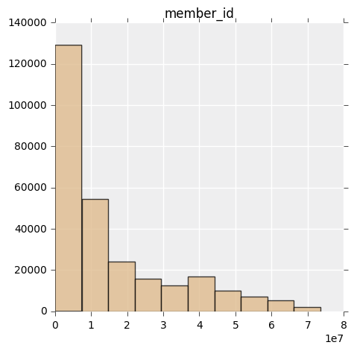

Member id is not uniformly distributed. So we decided to see the distributions of member ids for each loan status.

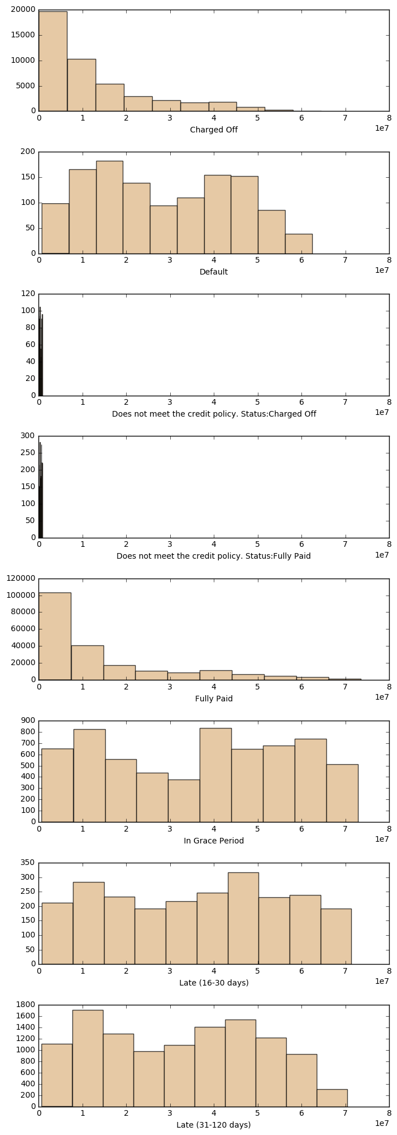

We immediately see, that some IDs are very good indicators of some status.

This trend, the relationship between the outcome and ID is a data collection problem (maybe not a problem, but trait). For prediction purposes we shouldn't consider such features, so we would remove that column in feature selection section. This is likely the case for the column “ID” as well, so we won’t explore it.

**Other features**

We see the distribution of people over zip codes.

We see that there are a lot of zip-codes that have more than 1000 people in there. That would allow us to make inference for each zip-code. On the other hand, it seems that zip-code *should not* influence much on loan status, so we wouldn't add it to final model. 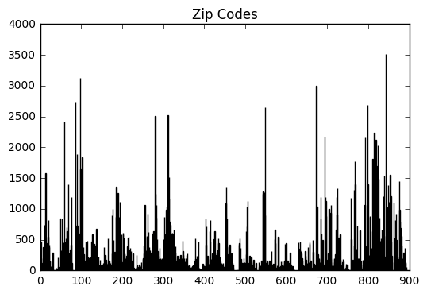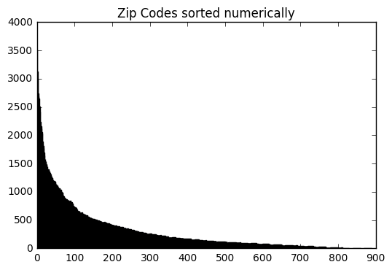

We have 5 features that contain date information.

ML algorithms can't deal with date columns explicitly. It's worth noting that information is mostly contained not in absolute date values, but differences in them (i.e. how much time has passed between some actions). We won't plot graphs to explore that fact, but we'll add this differences (for each pair of dates) to our model.

## **Recap**

After doing exploratory analysis, we did couple of observations and found some relationships, that are summarized here.

* There are a lot of missing values. Half of columns have some missing data. In total, 27.3% of the values is missing. Understanding how to deal with them correctly, needs expertise in the field, and much more time, so we'll perform the most common thing - change them into mean for numerical values and to 'NaN' string for categorical ones (that would be an individual category).
* There are a number of categorical features. Since most ML algorithms can't deal with them, we performed One-Hot-Encoding to get numerical representations of them. It's worth noting, that this approach can only work on categorical features, that have small number of unique values. Here, some columns had many unique values (like zip-code, which has 935 unique values). We won't use them in our model.
* Distributions of some features are too skewed, so we need to take logarithm of them.
* The predictor can take 10 different values. But distribution of these values is not uniform, classes are skewed. That means, that depending on the task (real-world application), we would need other metrics than accuracy.
* Some columns are highly correlated. Usually that's not a problem since in all models we would have some regularization term, that would prevent bad influence of these correlations.
* We fit Random Forest model and saw that there are not many features that this model used to predict an outcome. Also, we explored top relevant features, and detected, that IDs had large impact on prediction. That's a type of overfitting and to avoid it we would remove that column.

**Create and Train Model**

We will train and test our data using logistic regression, QDA, LDA, SVM, Decision Trees, and Random Forest models, AdaBoost, and Gradient Boosting.

There are a number of categorical features. Since most ML algorithms can’t deal with them, we performed One-Hot-Encoding to get numerical representations of them. It’s worth noting that this approach can only word on categorical features, that this approach can only work on categorical features that have small number of unique values. Here, some columns had many unique values (like zip-code, which has 935 unique values). We won’t use them in our model. Distributions of some features are too skewed, we need to take logarithm of them.

The predictor can take 10 different values. But distribution of these values is not uniform, classes are skewed. That means, that depending on the task (real-world application), we would need other metrics that accuracy. Some columns are highly correlated. Usually that’s not a problem since all models we would have some regularization term, that would prevent bad influence of these correlations.

**Feature Engineering**

Mostly, this part relies on results that we got in data cleaning part. Firstly, we perform all the transformations that were mentioned in the previous part. We separate target feature and also convert it to numerical instead of categorical, and instead of working with the date columns, we work with differences (in seconds) between each pair of dates. As seen in exploratory analysis,out_prncp vs out_prncp_inv and total_pymnt vs total_pymnt_inv are highly correlated. To retain information, we add new column as a difference between this correlated variables. To deal with NaNs, for numerical columns, we change it to mean of that column. For categorical features, we create new category called 'NaN'. We also remove categorical columns with many values.

**Make Predictions Based on Feature Selection**

The Random Tree’s built-in importance ranking computation assigns a number to each column, meaning how relevant it is for classification. It calculates an accuracy rate of 95% for the auto-feature selection model. After manual feature selection, we have improved accuracy rate to 98%.

Based on Random Forest model, we run Recursize Feature Elimination (RFE), Summizing, Normalization for finally predicting default rate.

We run random forest model one more time to get feature importances. Now, instead of KFold we use hold-out dataset to see whether model overfits.

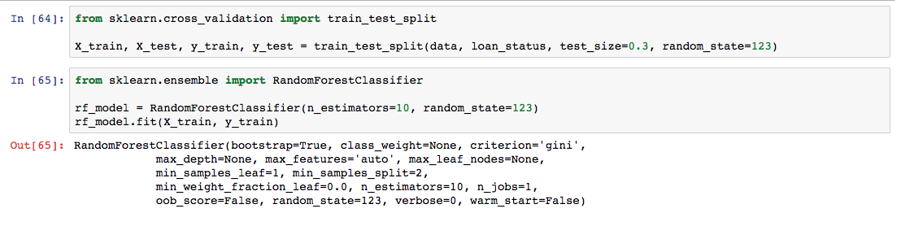

We now compute accuracy of prediction of test set:

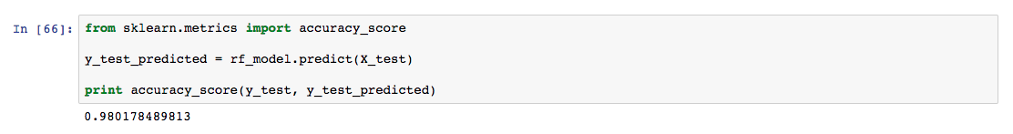

We see, that accuracy increased even more (0.955 -> 0.98). Now we look at importances for this model:

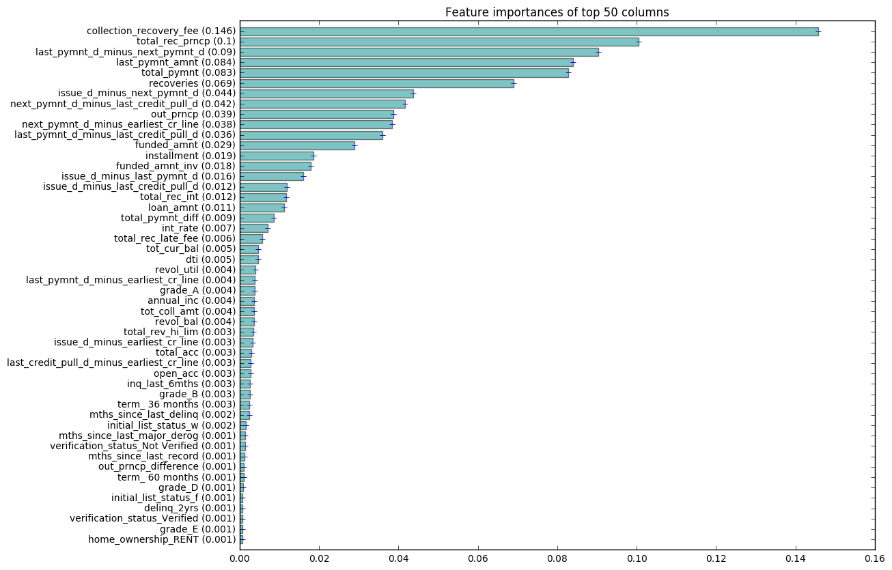

Now the features that are most important are quite different. In fact, the data predictors seem to be very important as well.

### **Recursize feature elimination**

As seen from RF model, there are not more than 50 features, that contain useful information.

We use that fact (concretely, number 50) to run RFE on random forest and see what feature it selects.

### **Summizing**

So, we proposed two methods to do feature selection. To make sure they both select relevant features, we look at how many features they both have.

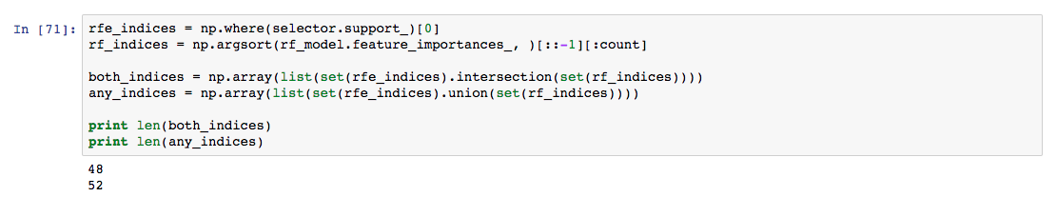

We see, that these two method got most of the features both. Since feature selection is just a set of heuristics, we'll assume that both of these approaches got relevant features and we will take all features they propose. That will give us 52 features in total.

### **Normalization**

As a final transformation, we'll normalize each column of dataset, so that each feature has value between 0 and 1.

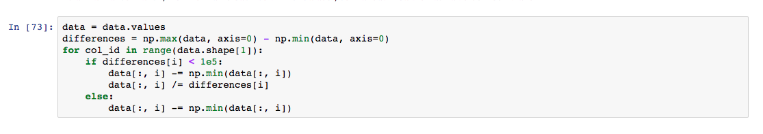

## **Models**

## **Predict Default Rate**

First of all, we have a lot of data to deal with, to select the model, we would only use a part of dataset - random 10%. If some algorithms would both have high accuracy, we would train them on whole dataset.

We will try following models:

* KNN
* Random Forest
* Decision Tree
* Logistic Regression
* SVM (Linear and nonlinear)
* AdaBoost
* Gradient Boosting

Each of them has its own hyperparameters to tune. We will use grid search with 5-fold cross-validation to find most appropriate set of parameters. After that, we'll test the model on test dataset, that contains 30% of the whole data. That would make results more stable and representative.

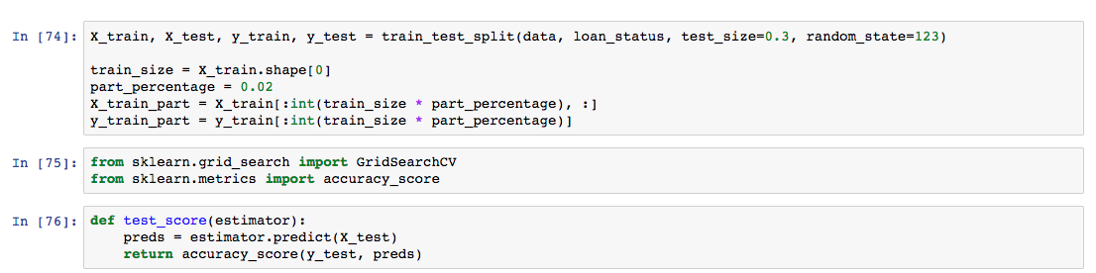

### **KNN**

Here we need to tune number of neighbors to use for prediction.

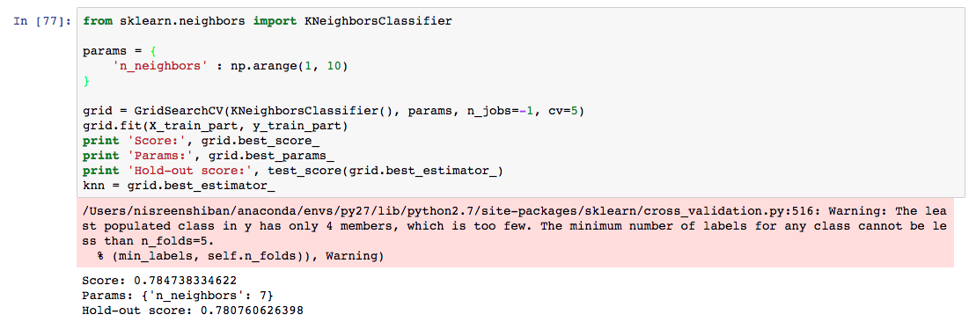

### **Random Forest**

Random forest has more parameters to set: number of estimators, split criteria, maximum features to account in each tree and max depth of each tree.

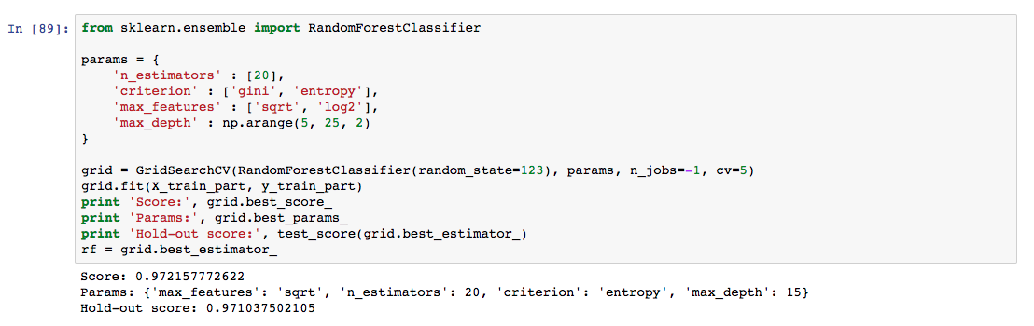

Once we found best parameters, we see whether accuracy improves when we increase number of estimators.

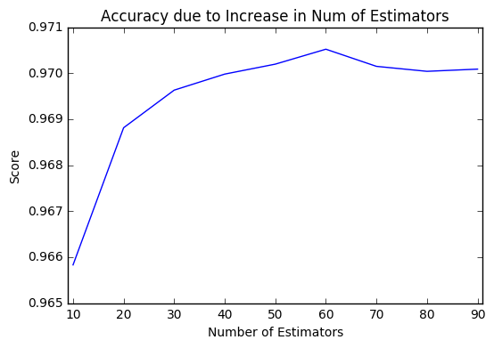

We can choose number of estimators equal to 20.

Decision tree seems rational here, since when prediction loan outcome we usually need to understand the underlying process of deciding. That's where decision trees are good at.

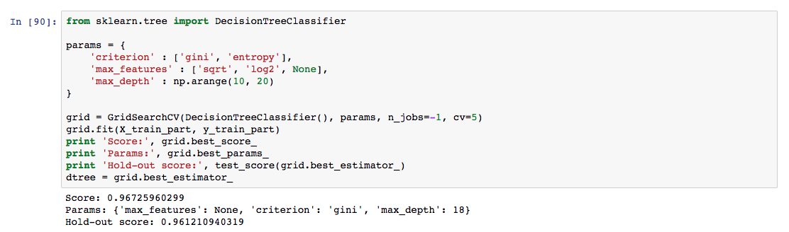

Logistic regression is the first thing to try in classification task. We use L2 regularization to penalize large weights in order to prevent overfitting.

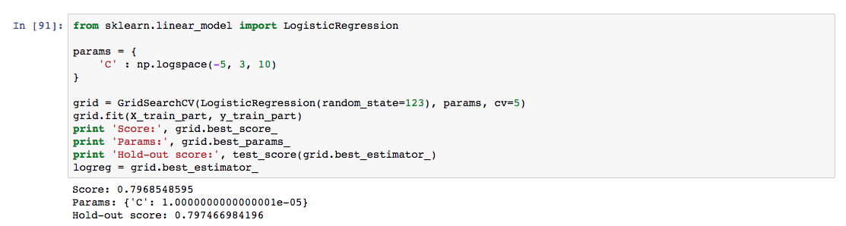

Linear SVM

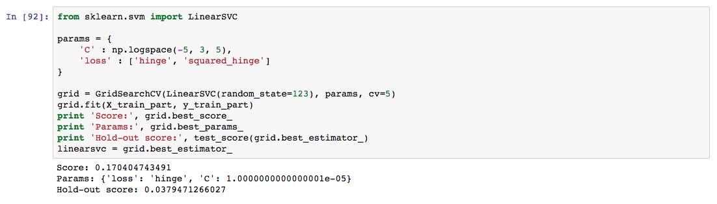

Nonlinear SVM

SVM allows to use kernels, so that the classification task is solved in high-dimensional, implicit feature space without ever computing the coordinates of the data in that space, but rather by simply computing the inner products between the images of all pairs of data in the feature space. Here we use the most popular RBF kernel.

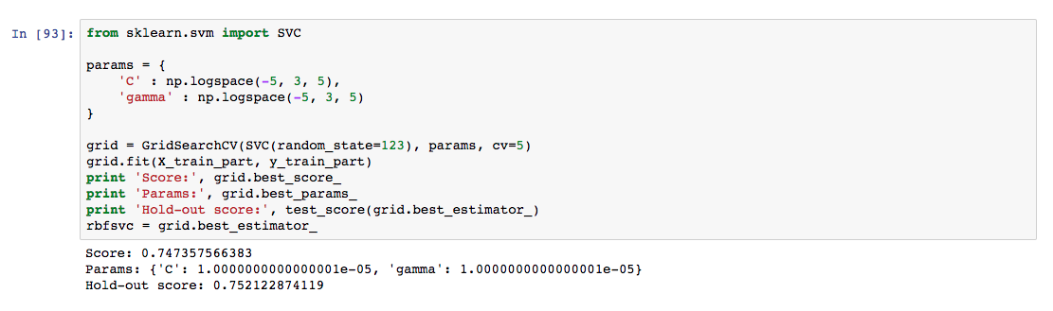

AdaBoost

Boosting is one of the methods that can find very complex non-linear decision boundary. The first algorithm among boosting methods is adaboost.

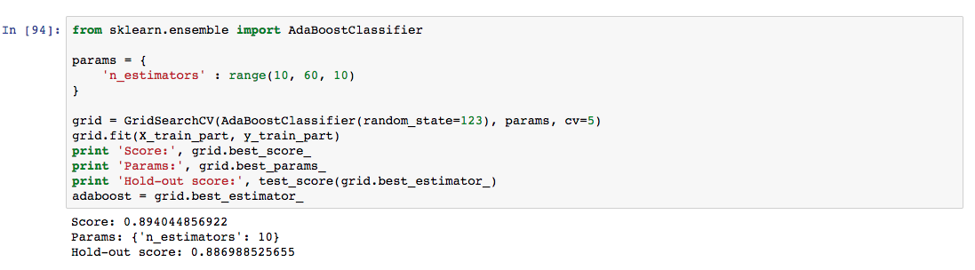

Gradient Boosting

Gradient boosting represents more general approach. It's usually more powerful than AdaBoost.

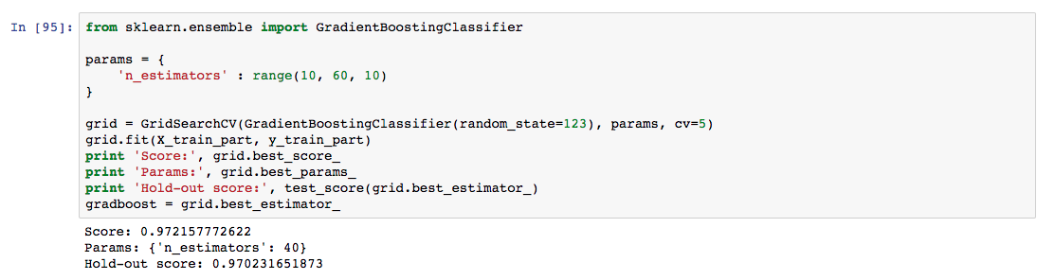

**Results**

Once all models are trained, we believe there could be a set of parameters that influence the model:

1. Speed and Efficiency

All proposed models can be built in a reasonable time on a single machine. As for testing time, all provided models are much quicker to test then train, so it’s also affordable. Number of parameters of each model is very small compared to size of dataset, so after training it consumes very little memory.

2. Metrics score

It is the main characteristic of the model. All others are just binary criteria – we won’t take a model if it doesn’t fit any of them. Among all the models that satisfy all other criteria, we pick the model with the highest metric score.

For each real problem we create our own metrics to optimize.

*Accuracy. That means we consider that all the examples are weighed equally. That is usually not true, and it’s not true in our problem, so that is not the best metric to choose.

*F1-score. This metric account for class imbalance. As seen before, some classes have small number of examples. That gives the effect that each class is weighted inversely proportional to class size. This metric is also not designed to this task. Though it would give more reasonable results, since we’ll penalize for not paying attention to some class. The F1 score is based on precision and recall, and it can be used in multi-class classification by calculating a multiclass weighted average. Precision (also called positive predictive value) is the fraction of retrieved instances that are relevant, while recall (also known as sensitivity) is the fraction of relevant instances that are retrieved.

3. Interpretability

In loan prediction task, it would be great if humans can evaluate the model and see how it makes its decision, so that one could find perhaps unreasonable decisions/logic in algorithm’s thinking. Not all the models provide a nice interpretation.

4. Variance

How different can results be when we train an algorithm multiple times. That gives us the confidence about the prediction. We prefer variance to be small, but there’s a bias-variance tradeoff.

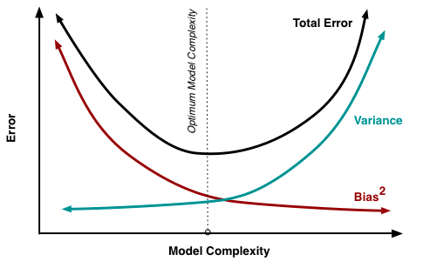

As final a metric we take the F1 score. We also plot the confusion matrix to understand where algorithm makes mistakes. We now evaluate each algorithm and choose the best one to our task.

KNN

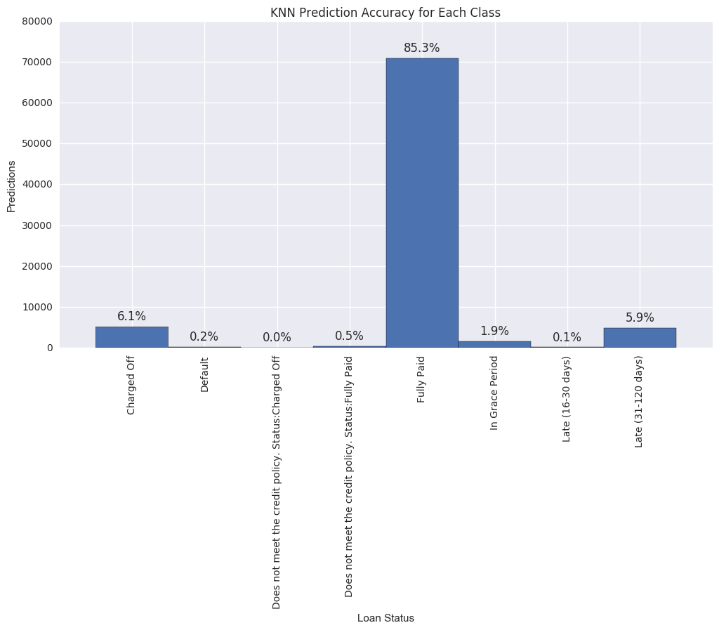

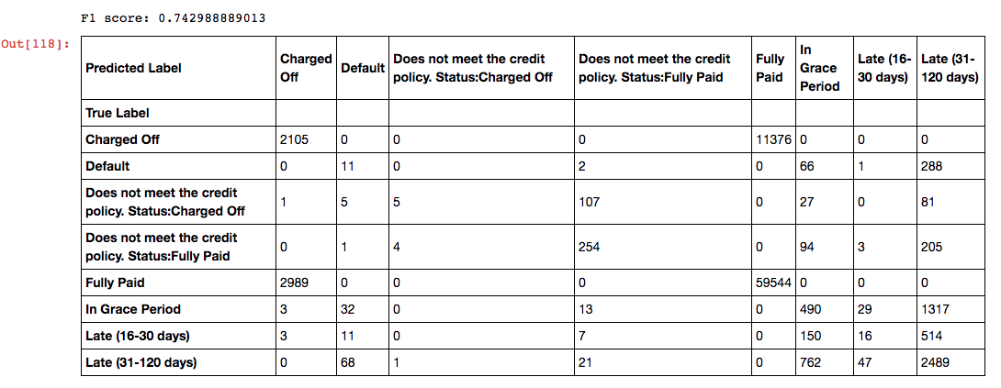

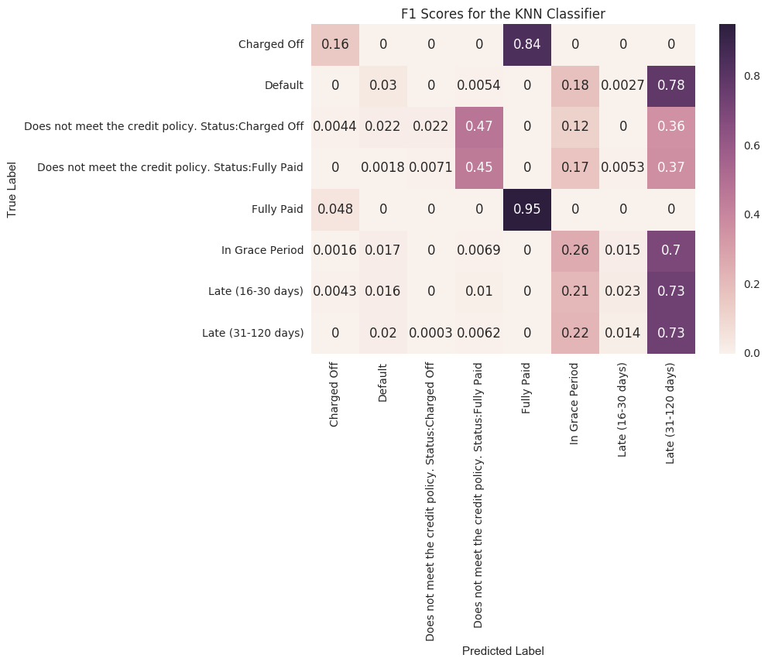

We see, that even the simplest classification model gives us reasonable score. We look at the model parameters:

* Memory: Knn needs to store all dataset to make predictions. This dataset is already large, so it can be impossible to use it in practice.
* Interpretability: the model has a nice interpretation: we can show nearest neighbors that affected the algorithm's decisions. These are people similar to person we're trying to predict.
* Variance: this model highly depends on the exact dataset. For prediction we only take into account 7 neighbors, that's why it has high variance.
* F1-score: such score is a good start. To understand how good it is, we'll later compare them to other models.

Random Forest

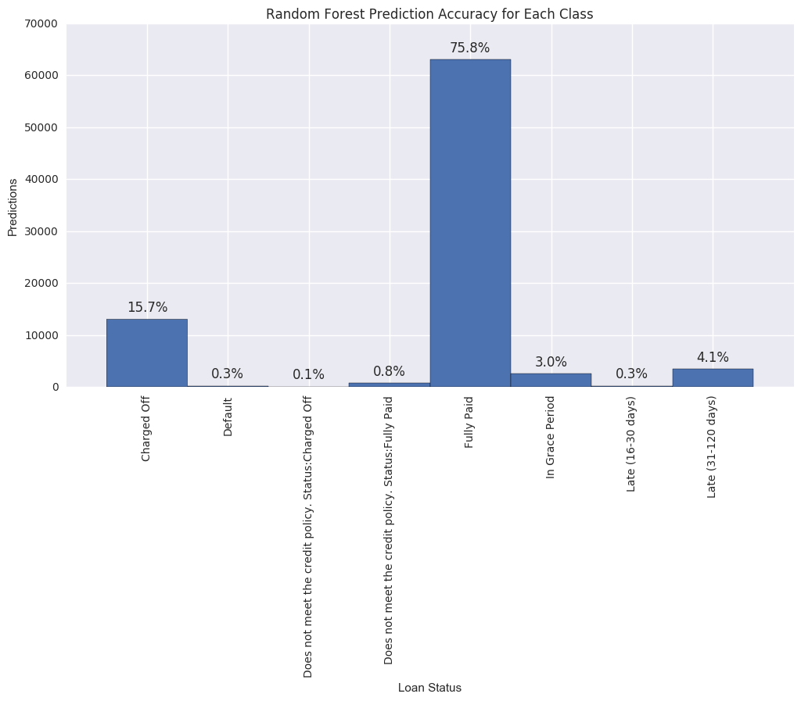

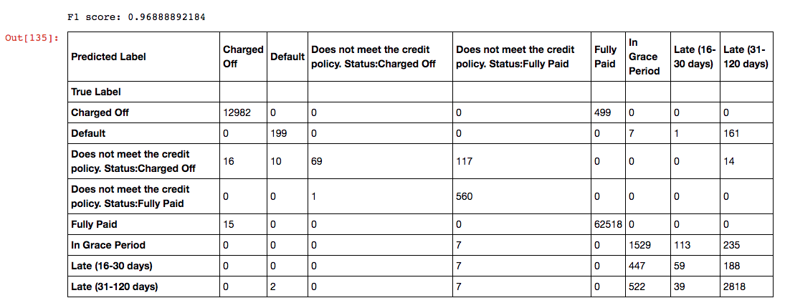

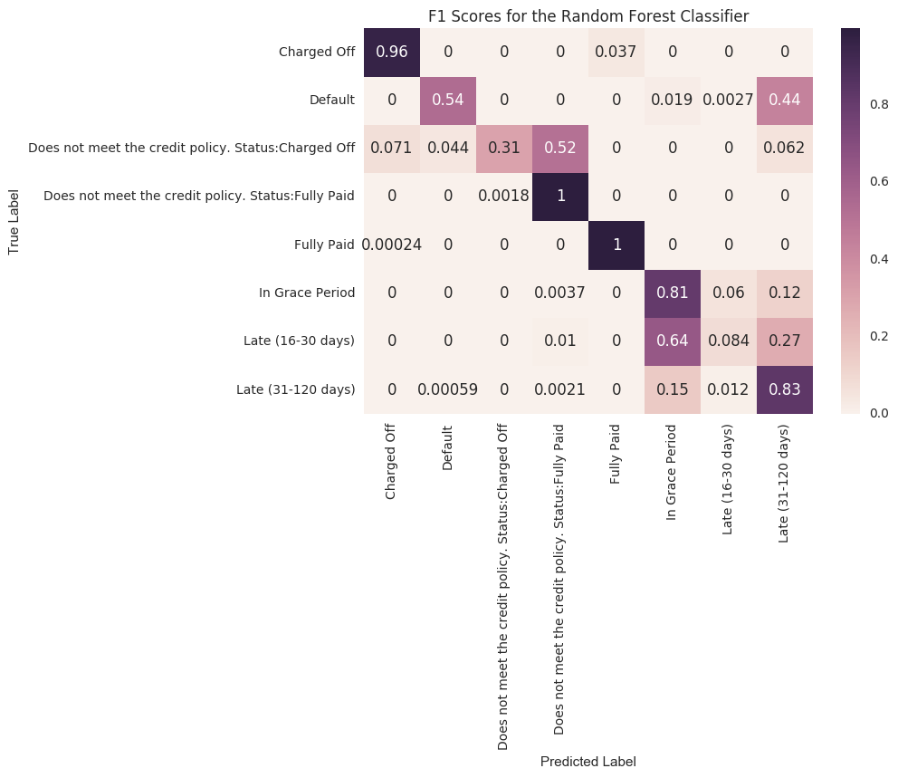

* Memory: memory consumption is pretty small.
* Interpretability: since RF is an ensemble method, it combines a lot of decision trees together and that's why it's not well interpreted.
* Variance: Since we average a lot of predictions, variance for this method is low.
* Metrics score: as we see, random forest produces very high F1-score.

Decision Tree

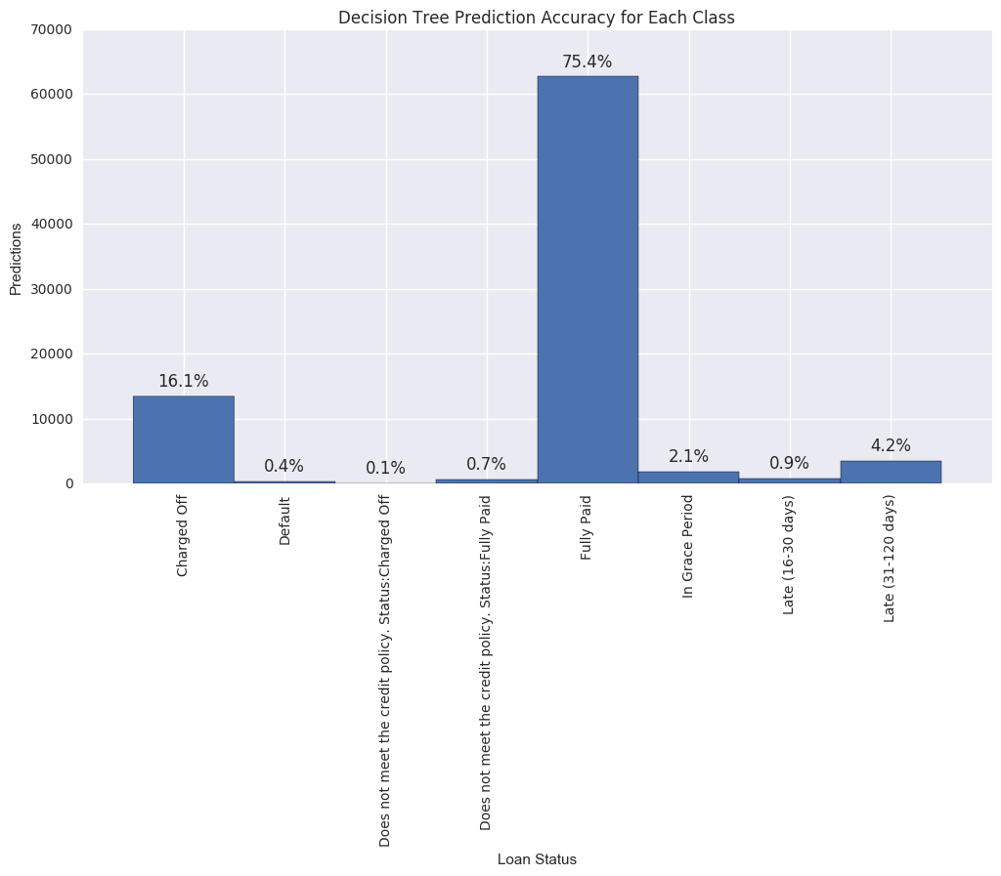

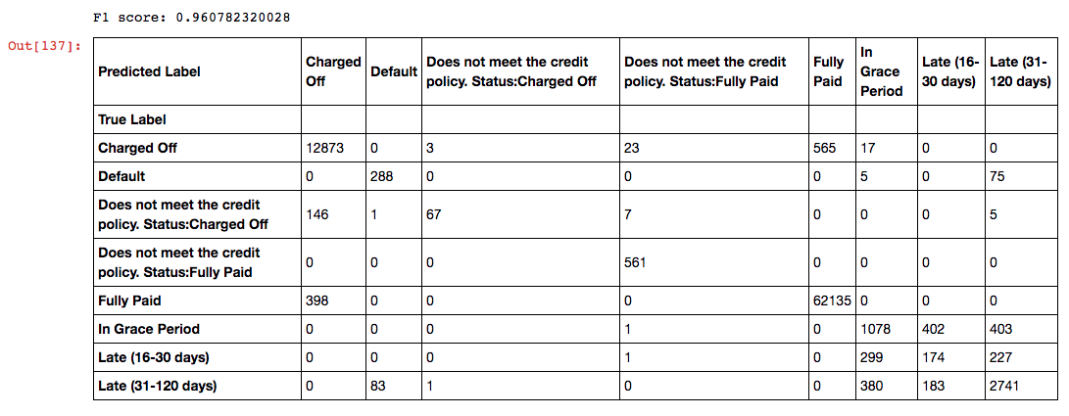

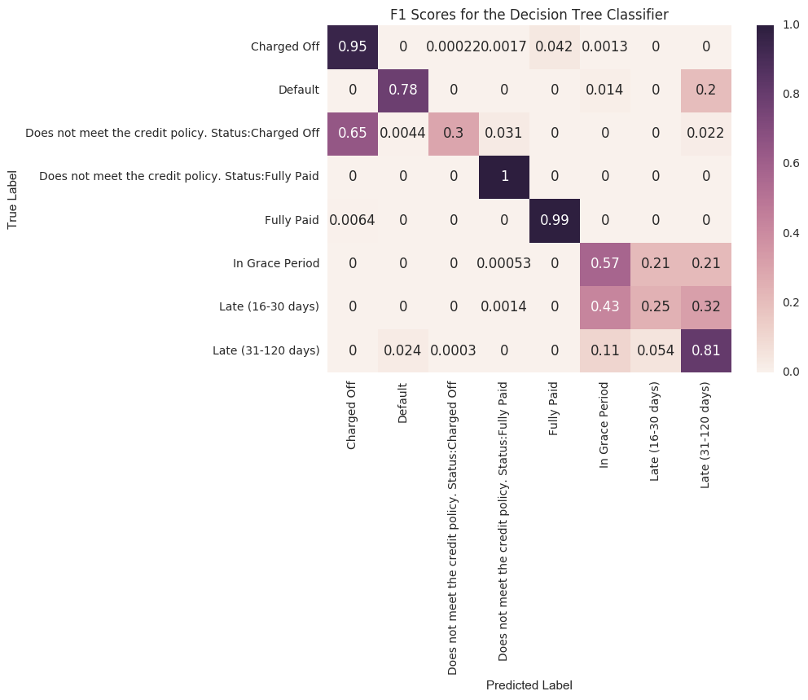

* Memory: memory consumption is pretty small.
* Interpretability: decision tree is great at understanding the underlying progress. We can see what decisions were made at each step of the algorithm.
* Variance: The exact tree shape highly depends on the training data. Even small changes can result into big changes in final model. This model has high variance.
* Metrics score: as we see, decision trees give us pretty high score. That means we can predict each person's loan status by "asking" series of questions about values of features.

Logistic Regression

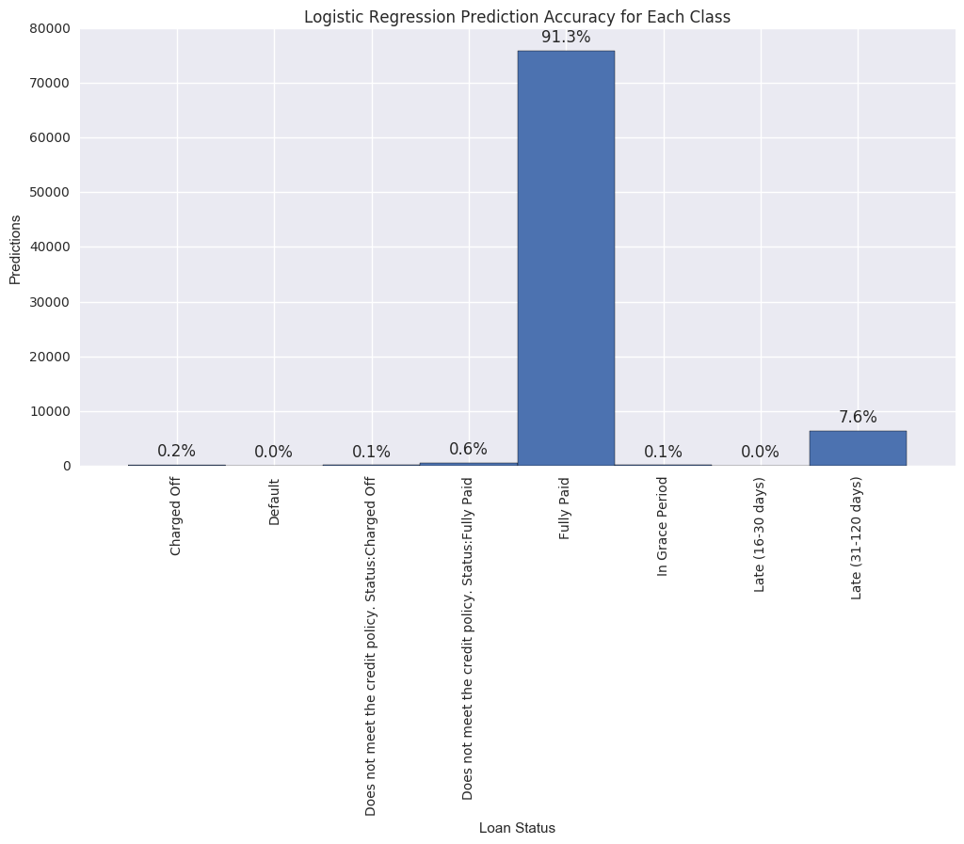

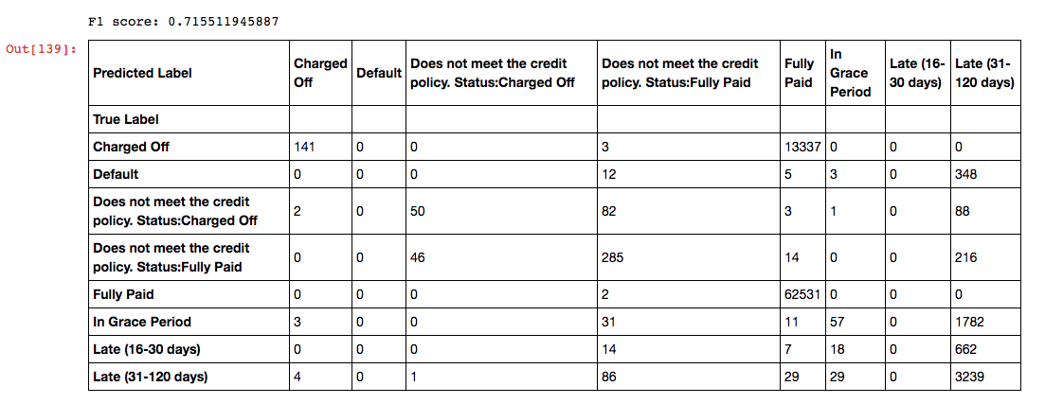

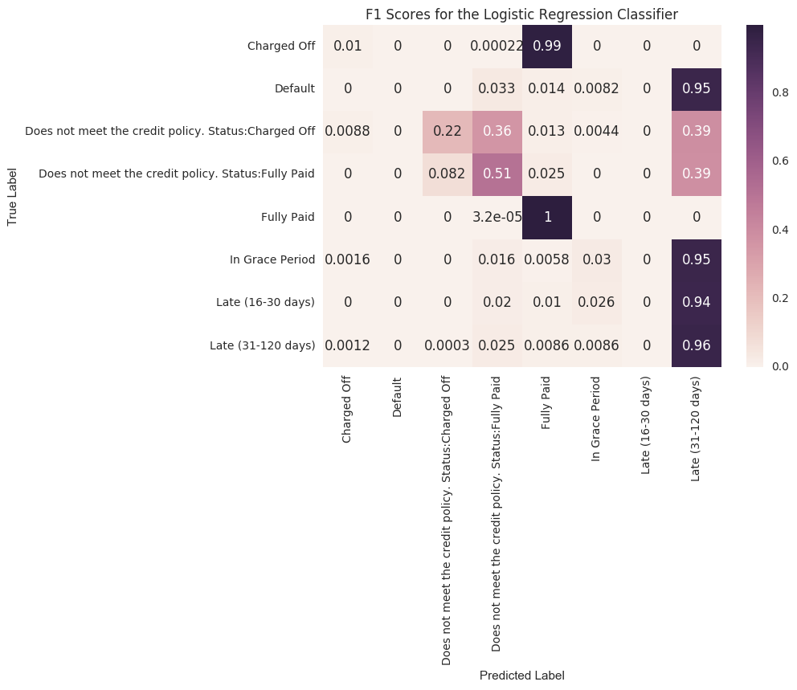

* Memory: memory consumption is pretty small.
* Interpretability: logistic regression is a linear method so we can nicely interpret it.
* Variance: linear models are known to have small variance, its results wouldn't very much.
* Metrics score: score is pretty low. That means that linear methods doesn't correctly describe the underlying relationship.

Linear SVM

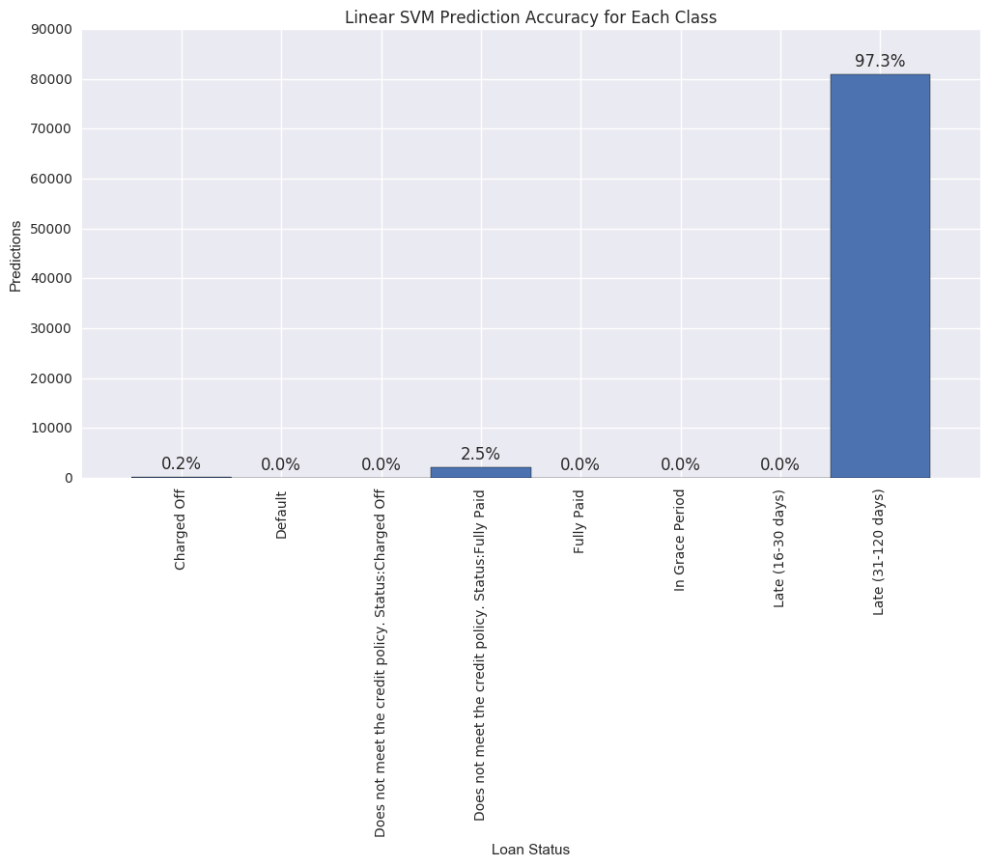

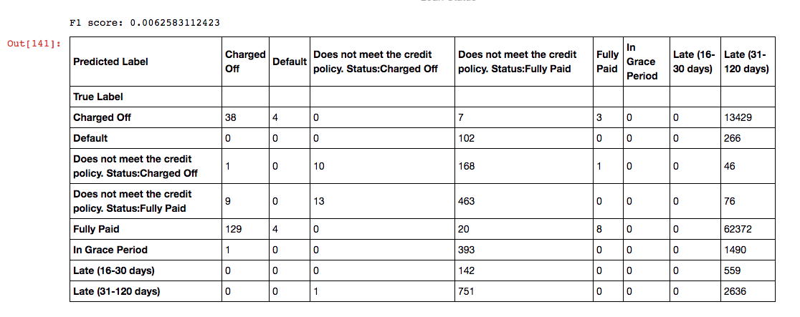

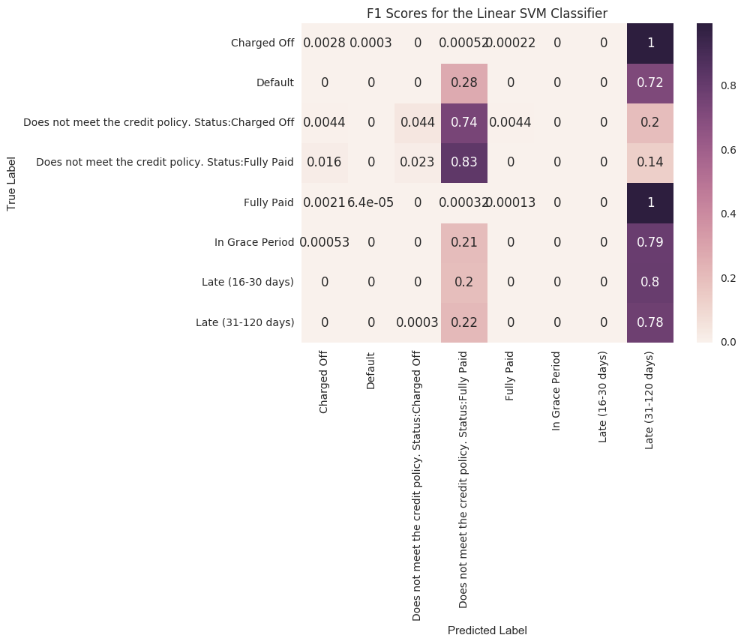

Analysis of this method is almost the same as for logistic regression. As we see, linear methods are bad for this task.

Nonlinear SVM

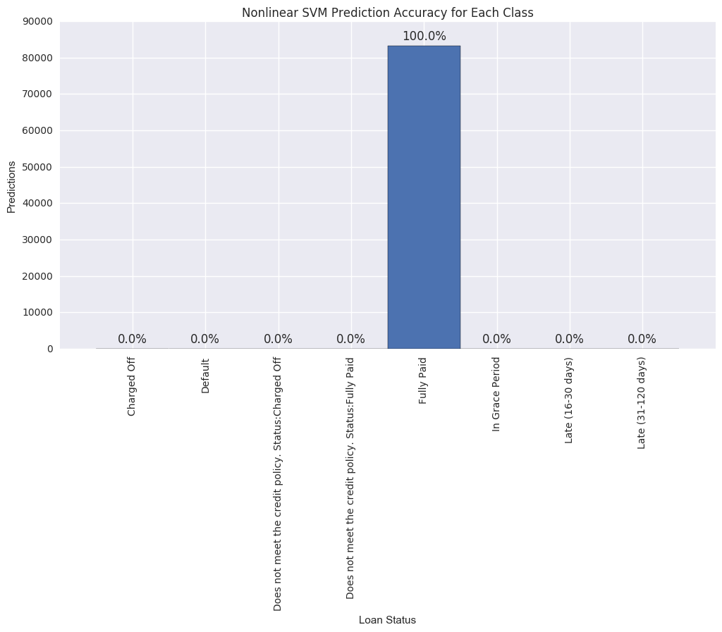

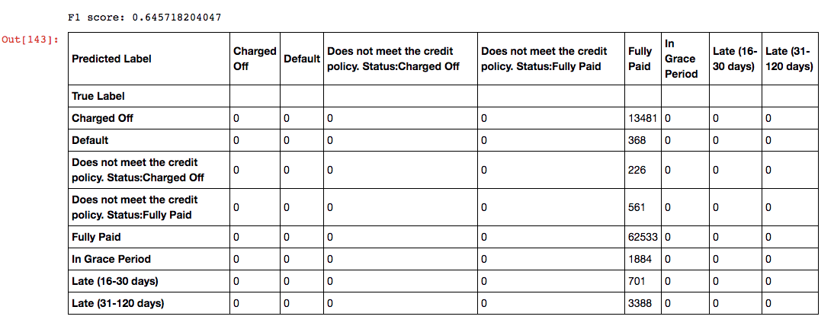

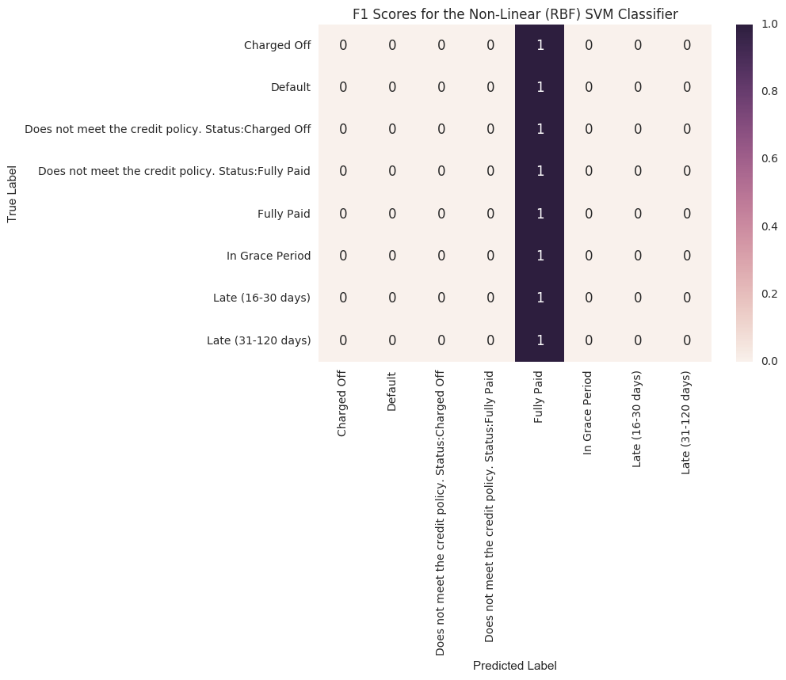

Such low F1-score shows that probably the model parameters were not tuned nicely.

I wasn't able to tune them more precisely because the complexity of training Non-linear SVM is *O(N2M)*, where *N* is number of samples and *M* - number of features. And that's too much for this size of dataset.

AdaBoost

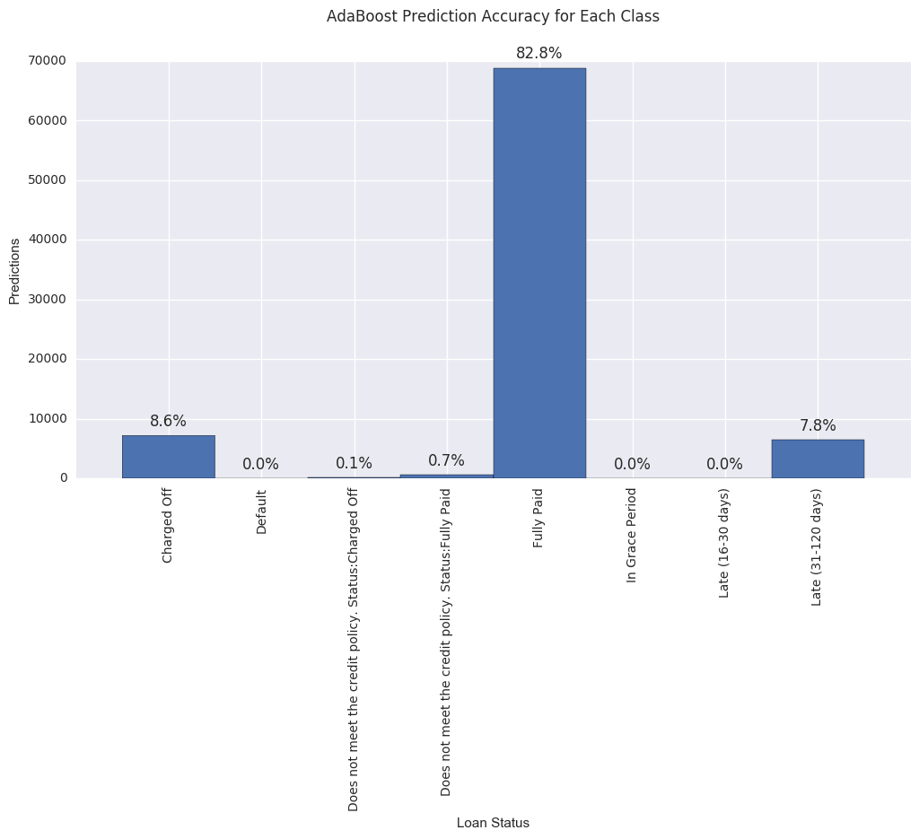

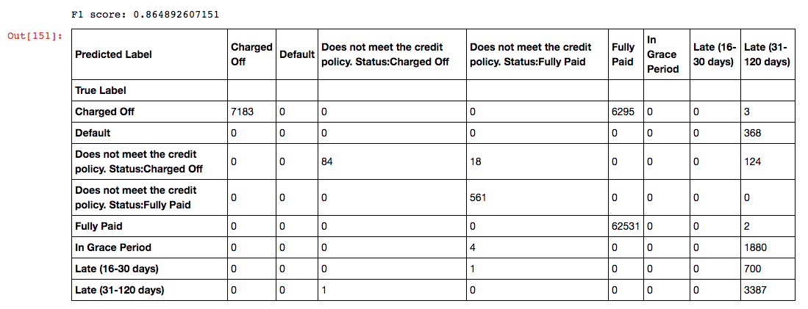

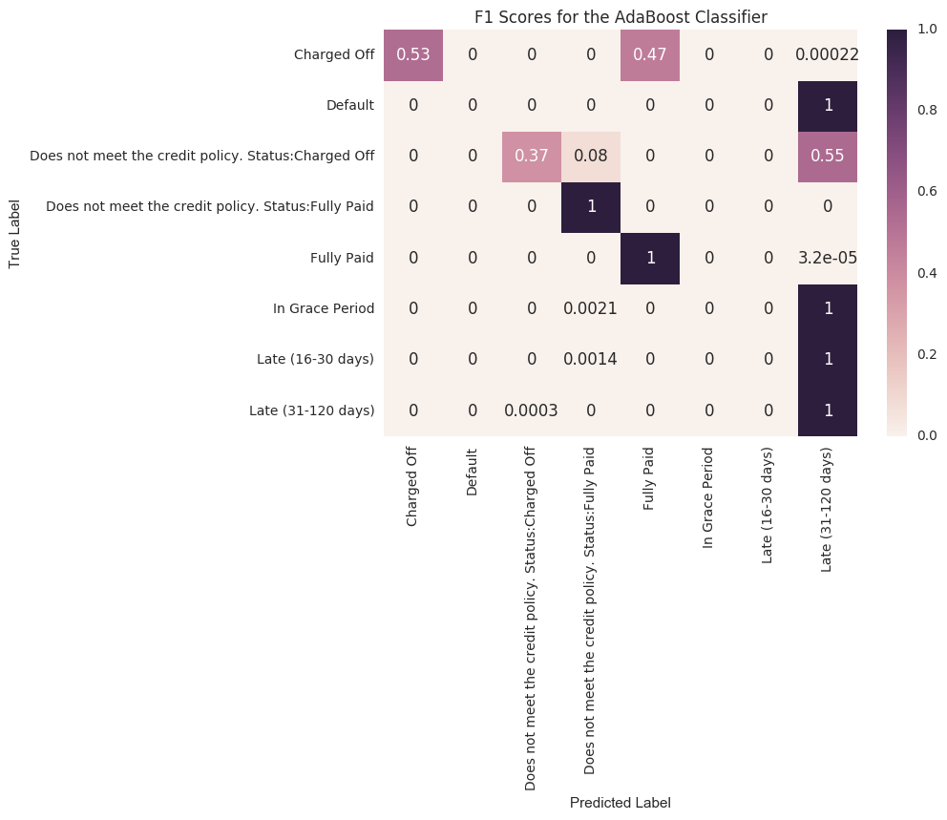

AdaBoost has similar properties to Random Forest. The basic idea of combining weak classifiers is just the same. Apparently, Random Forest fits better here. Because other characteristics are similar, RF is for sure better for this task.

Also it can have high variance since it works poorly with outliers.

Gradient Boosting

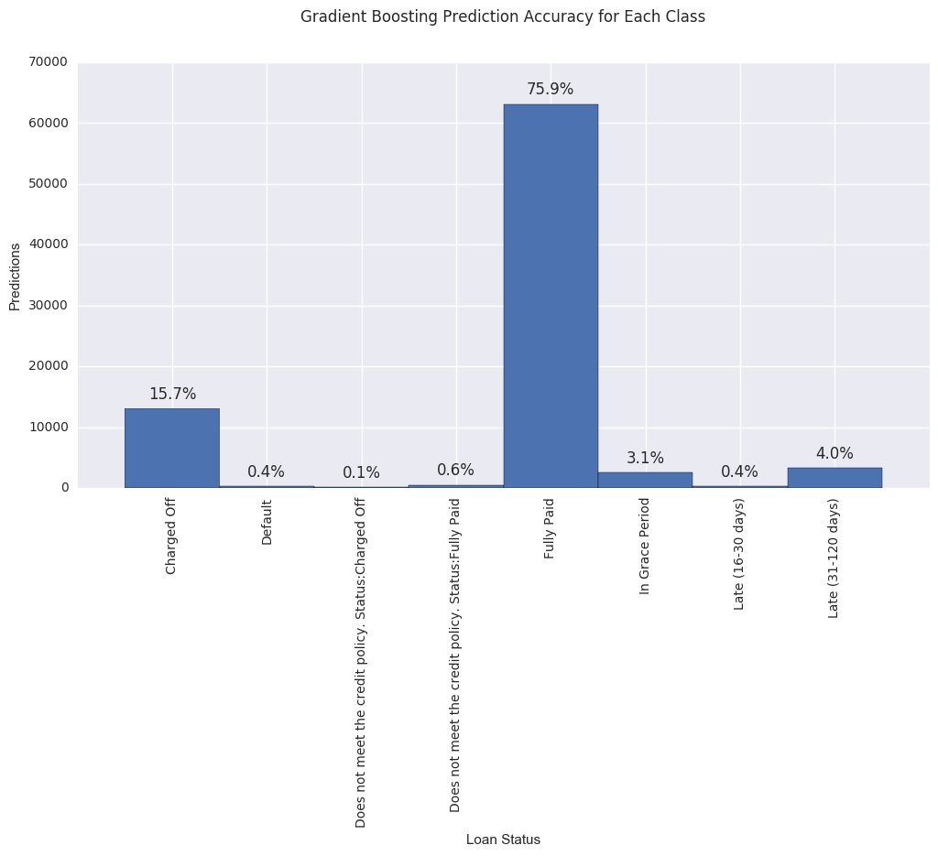

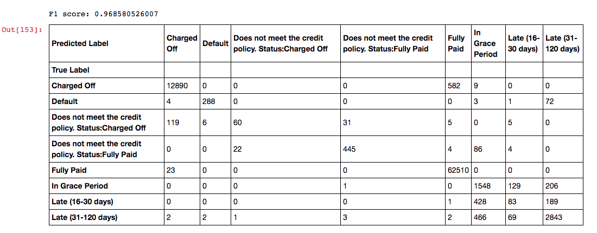

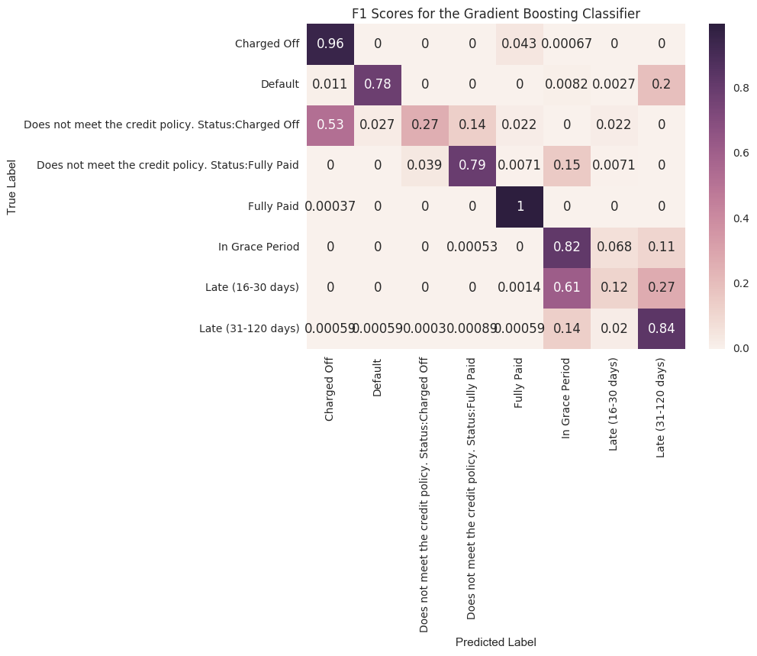

GB is another to combining classifiers. It also lacks interpretability.

But as we see, it has high F1 score, comparable to random forest model with makes it also possible for a best model.

The final choice of the model is not obvious. As stated above, it relies on the specific goal we want to accomplish.

For sure we need high accuracy and F1-score, so that leaves us with following models:

* Random Forest
* Decision Tree
* Gradient Boosting

Scores of these models are comparable one to another. But decision tree has the property that it's interpretable, that can be critical in this problem. Also, the training time for this model is lowest.

We choose Random Forest to be our model based on these criteria.

The reason we think Random Forest Classifier performed best is because random forests combines a collection of very deep trees without paying the price of high variance that come with depth. Trees that are deep have lower bias and so can capture more complicated patterns in data, but higher variance. By averaging over a large number of deep trees trained on independent samples of our data and on different subsets of predictors, we reduce the model's sensitivity to the noise in the data, so the model is less likely to fit to noise and thus less likely to overfit.

The following are alternative methods we attempted.

We considered modeling binary classification in a simple “Fully Paid” and “Default” measurement (**1 and 0** respectively).

Here were some findings from data exploration:

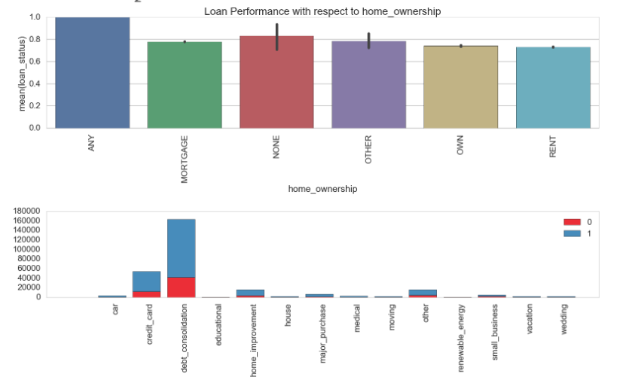

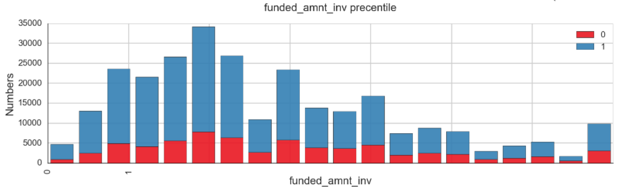

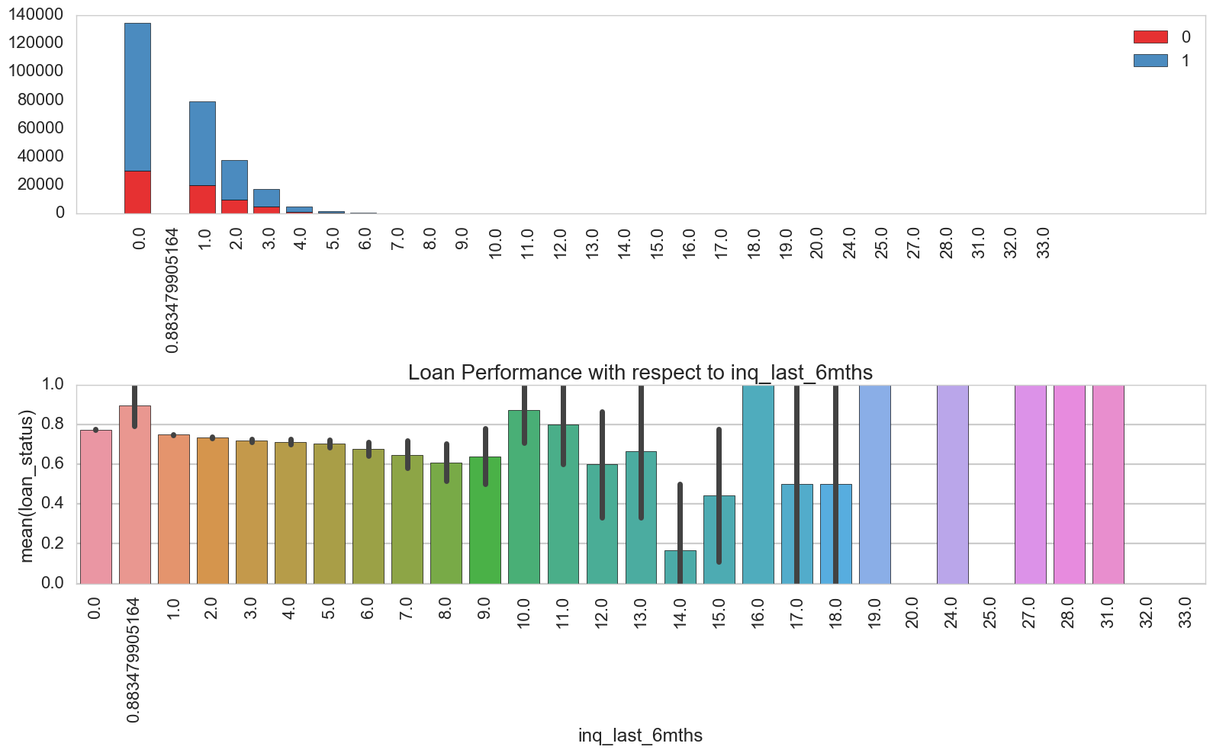

Additionally, textual analysis of employment titles was used to create a new column called “fully_paid_predictions” encoding with 0,1,2,3 the three professional titles including “bank,” “university”, and “hospital” we thought correlated highly with fully paying the loans.

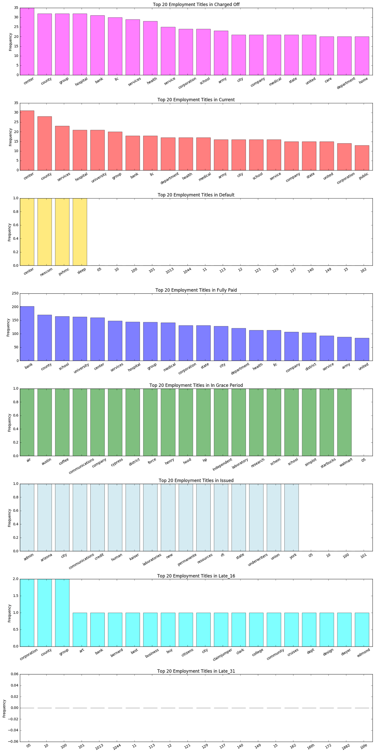

Here were the findings after fitting several models:

KNN



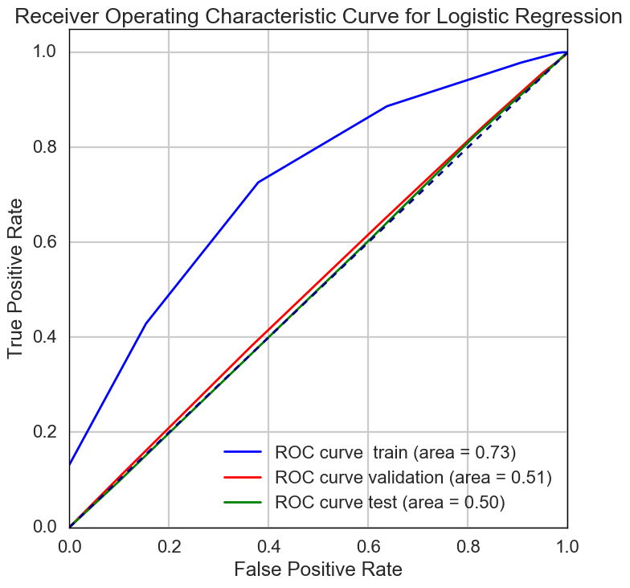

Random Forest



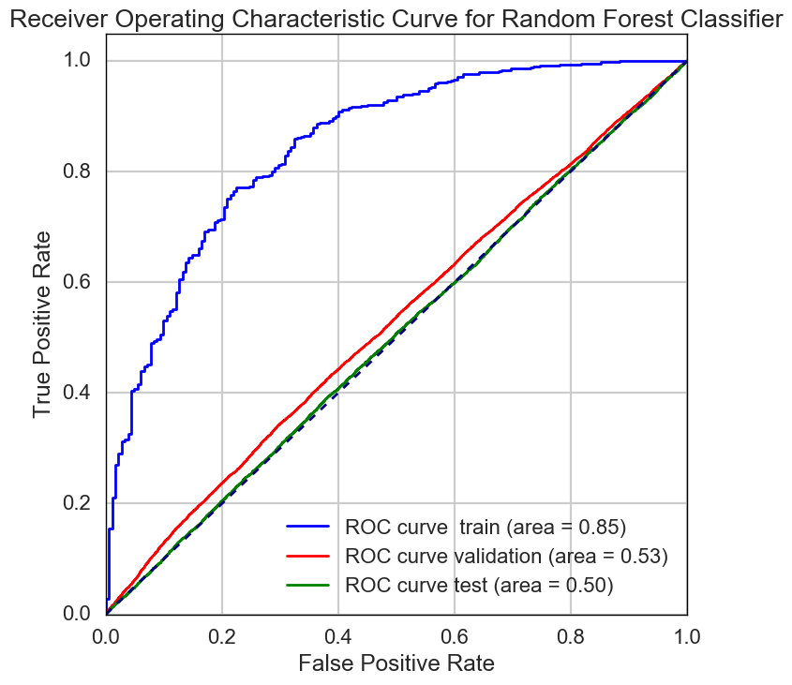

Decision Tree



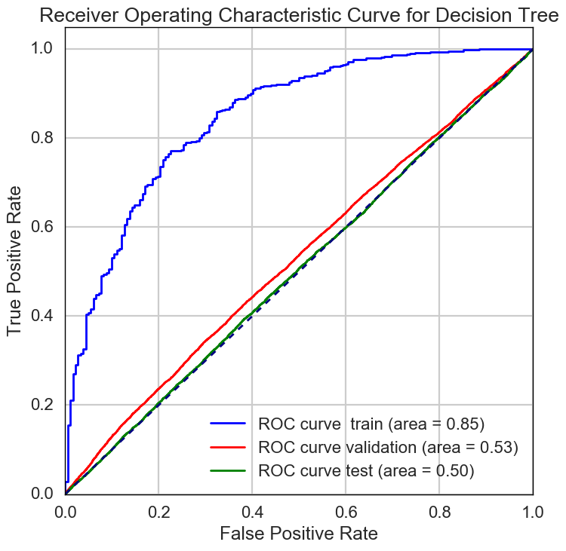

Logistic Regression



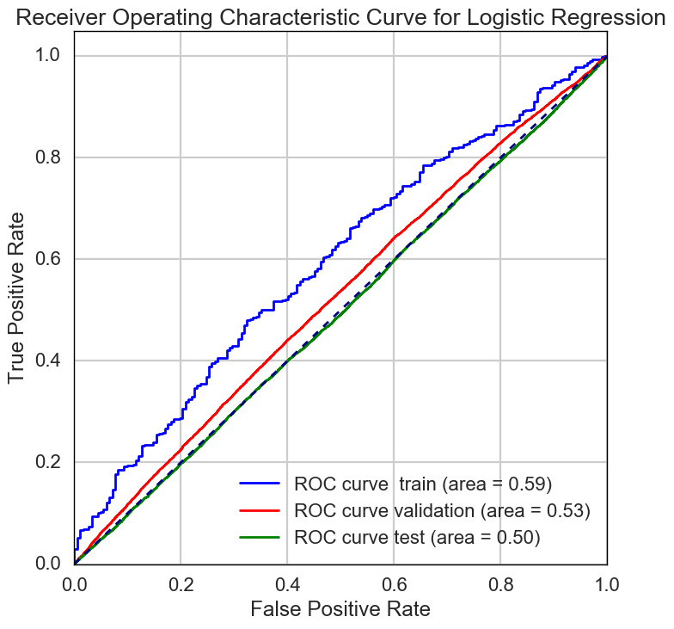

Linear SVM



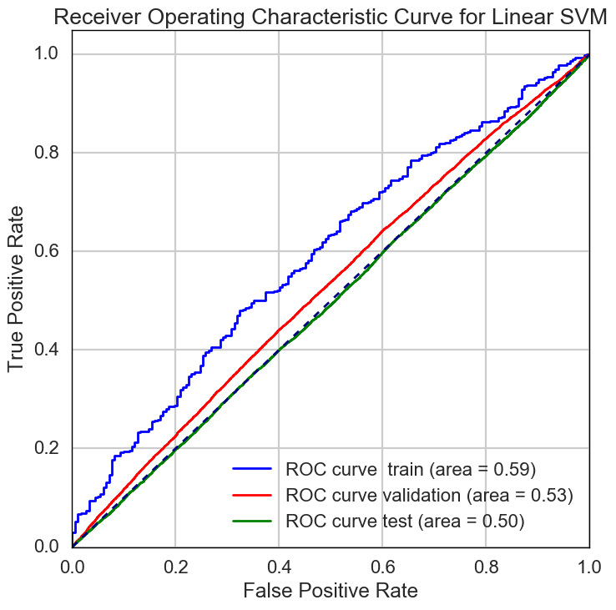

Nonlinear SVM



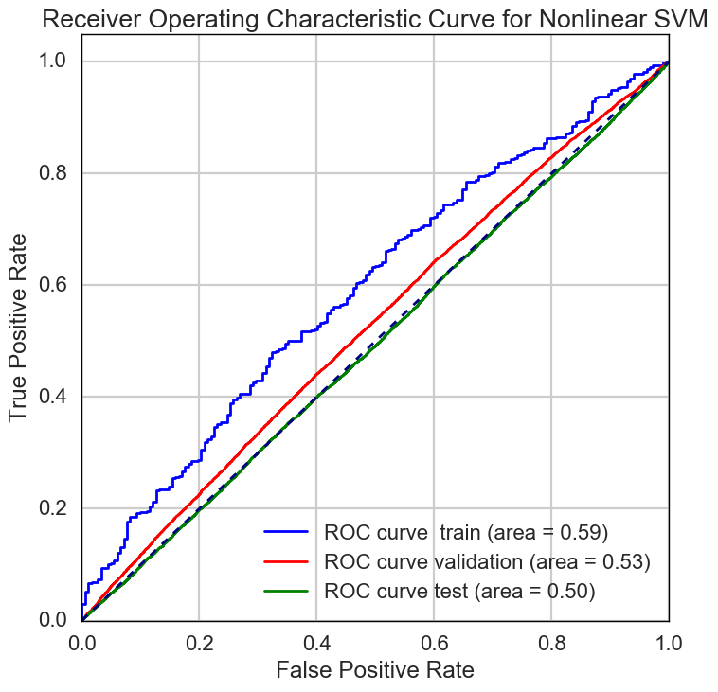

AdaBoost



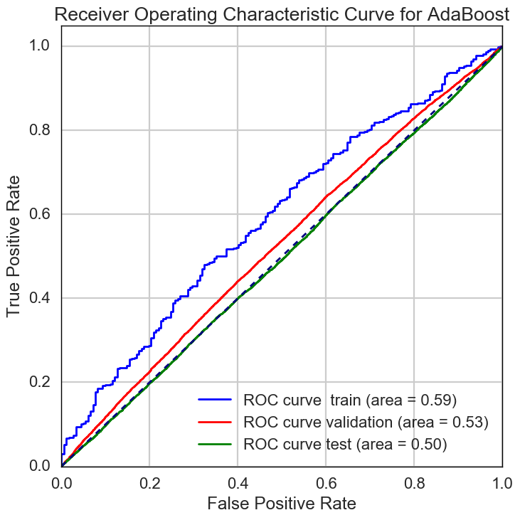

Gradient Boosting





Looking at these ROC curves, our binary classification method does not fare well for any of the models, which is why we decided to go with the multi-classification method.

Profiles for each classification

Based on the data exploration here, we came up with profiles for those who are likely to “fully pay” vs those are likely to “default.”

Fully paid profile:

An individual who is likely to pay his loan on Lending Club has the following characteristics:

* Employment for more than 2 years
* Has mortgage or owns a home
* Has the loan for the term of 36 months
* Has less than 2 personal finance inquiries in the last 6 months
* Has less than 2 delinquencies in the last 2 years
* Has no derogatory public record
* Wants a loan for home improvement or to pay for a large purchase
* Has less than 2 revolving trades opened in past 12 months
* Has less than 6 revolving trades opened in past 24 months
* Has an initial listing status of the loan as Whole on Lending Club
* Has had no more than 2 late fees in the last 12 months
* Has more than 2 finance trades
* Works in finance, academia, or medicine

Default profile:

An individual who is not likely to pay his loan on Lending Club has the following characteristics:

* Employment for less than 2 years
* Rents a home
* Has the loan for the term of 60 months
* Has more than 2 personal finance inquiries in the last 6 months
* Has more than 2 delinquencies in the last 2 years
* Has at least 2 derogatory public record
* Wants a loan for debt consolidation or to pay credit card debt
* Has more than 2 revolving trades opened in past 12 months
* Has more than 6 revolving trades opened in past 24 months
* Has an initial listing status of the loan as Fractional on Lending Club
* Has had more than 2 late fees in the last 12 months

Future direction

We believe that our model has taken many factors into account and uses a strong metric, but there is much more that can be done and a lot of room for improvement. Feature engineering is a method that we attempted by adding some columns. Textual analysis could be performed more closely, and we can form columns that encode information about what people have described is their purpose to take out the loan. We can additionally separate our data into smaller sections based on the employment type of the individuals that could tell us a bit more about the likelihood of default. Of course, there is also more cross validation and regularization that could be used to improve our models.

We also can make our method of prediction accurate over time (through 2007 to 2015). We could train our weighted models yearly (with different weights accounting for the imbalance in class proportions) on each of our logistic regression, QDA, LDA, SVM, Decision Trees, and Random Forest models. Although we dabbled a bit with this idea, when we saw that our Random Forest model was performing very well, we abandoned this side project. We still believe, however, that making